ARTICLE INFO
AUTHOR’S AFFILIATIONS
Tiara Nandita Putri¹
Nugroho Eko Wirawan Budianto²
Lusiani Tjandra³

CORRESPONDING AUTHOR
Nugroho Eko Wirawan Budianto
E-mail:
nugrohoewb@uwks.ac.id

Article history
Received
Revised
Accepted
Available online
Putri, T. N., Budianto N. E. W, Tjandra, L. (2024). Antibacterial Effectiveness of White Cempaka Flower (Michelia alba dc) Against Growth of Corynebacterium diphtheriae. Jurnal Ilmiah Kedokteran Wijaya kusuma, 12(2), XX-XXX
http://doi..

Antibacterial Effectiveness of White Champaca Flower (Michelia alba dc) Against Growth of Corynebacterium diphtheriae

Tiara Nandita Putri¹ , Nugroho Eko Wirawan Budianto² , Lusiani Tjandra³

Abstract

Background: One of the nutritious plants that is often used by people is the white cempaka flower or Michelia alba. Michelia alba flowers contains secondary metabolites of alkaloids, steroids, terpenoids, saponins, flavonoids and phenols. Methods: Experimental research method with post test only control group design using Cup-plate technique method. Results: The results of this research are that the minimum inhibitory concentration gainst the growth of Corynebacterium diphtheriae bacteria at a 20% concentration is 42.16 mm, the concentration of 40% is 47.21 mm, the concentration of 60% is 51.66mm, while at the concentration of 80% the average diameter of the inhibitory zone is 54.49 mm and also at the concentration of 100% the average diameter of the inhibition zone is 54.69 mm which is the average diameter of the largest inhibition zone. The negative control with an inhibitory zone diameter of 0 mm while the positive control with an inhibitory zone diameter of 44.21 mm. Conclusion: The conclusion of the research was that white cempaka flower extract (Michelia alba dc) in concentrations (20%, 40%, 60%, 80%, and 100%) had antibacterial effectiveness against the growth of Corynebacterium diphtheriae and at a concentration of 100% it is the most effective concentration in inhibiting the growth of Corynebacterium diphtheriae bacteria because it produces the largest inhibition zone compared to other concentrations and is classified as a very strong response.

Keywords: Michelia alba; Corynebacterium diphtheriae; Antibacteria

Original Research Article

INTRODUCTION
Disease patterns due to infection still dominate (Putra, 2019). One of the infectious diseases is diphtheria, which is a disease caused by the pathogenic bacteria Corynebacterium diphtheriae (Alawiyah, 2019). The treatment used in infectious diseases is the administration of antibiotics. In diphtheria, antibiotics are given with the aim of inactivating toxins and eliminating Corynebacterium diphtheriae (Putra, 2019). Giving antibiotics to patients can also cause side effects for sufferers. Therefore, scientists want to study the benefits of plants as medicines according to scientific standards (Safrina, 2022). Various types of food processed from spices and medicinal plants are known to have various properties ranging from eliminating colds, treating flu, coughing, to being believed to treat diabetes, cancer, and high blood pressure. The thing that attracts attention is that the results of modern scientific research support some of these claims, where it is proven that processed spices and traditional medicine products contain various types of phytochemical compounds that have certain physiological properties for the body (Batubara and Prastya, 2020). One of the plants that has been used as medicine by the community is the white cempaka flower or Michelia alba. Various parts of the cempaka plant can be used as medicine for diseases, including fruit, flowers, leaves, bark, roots, and sap (Maesaroh and Özel, 2021). In the research conducted on white cempaka plants, namely by using methanol extract of cempaka flowers. This study used extract concentrations of 0.05%, 2%, 4%, 6%, and 8% in the antibacterial activity test. The test results presented that the methanol extract of white cempaka has the potential to inhibit bacterial growth. It is illustrated that the higher the concentration used, the greater the diameter of the inhibition zone produced (Munira et al., 2021). So further research is needed on white cempaka flowers. White cempaka flower (Michelia alba dc) is included in one of the plants that can inhibit the activity of bacteria that cause infection (Safrina, 2022).
Based on the description above, the researcher is interested in conducting a study on how much antibacterial effect of white cempaka flower extract on the growth of Corynebacterium diphtheriae bacteria entitled "Test of Antibacterial Effectiveness of White Cempaka Flower (Michelia alba dc) Against the Growth of Corynebacterium diphtheriae".

MATERIALS AND METHODS

Sample Size
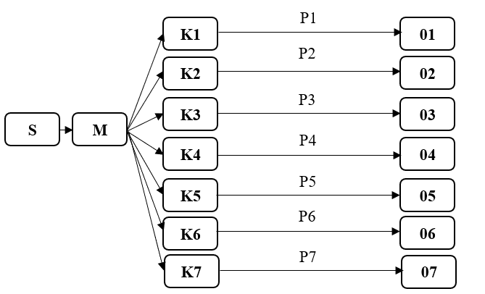
This study used a Post-Test Only Control Group using a simple random sampling method. Sampling in this study was calculated using the Federer formula. In this study, there were 7 groups of 4 treatment groups (20%, 40%, 60%, 80%, 100%) and 2 control groups. So, the total number of samples used was 28 because each sample had 4 repetitions. This study has obtained ethical approval from Faculty Medicine Universitas Wijaya Kusuma Surabaya with Certificate Number 43/SLE/FK/UWKS/2024. Note:
S: Sample
M: Mueller Hinton Agar (MHA) Medium
K: Research Group
P: Treatment
O: Observation

Materials Preparation
Sterile distilled water, suspension Corynebacterium diphtheriae, white champaca flower extract (Michelia alba) with concentrations of 20%, 40%, 60%, 80%, 100%, Mueller Hinton Agar, erythromycin antibiotic.

Equipment Preparation

Beaker glass, bunsen lamp, autoclave, incubator, sterile cotton swab, pipette, venier calipers, measuring cup, cork borer, handscoon. Sterilize all tools to be used with a pressure of 1 atm and a temperature of 121ºC in an autoclave for 15 minutes.

Extraction of White Champaca Flower

Fresh white cempaka flowers were cut into pieces and dried using an oven so as not to affect the chemical content therein then 500 grams of powder was taken and put into a macerator. Next, the white cempaka flower powder was soaked in ethanol until it was completely submerged. Followed by a filtering process that is repeated at least once. Perform evaporation using rotavapor until the extract is perfect and a thick extract of white cempaca flower is obtained.

Preparation of White Champaca Flower Solution
In this study, white champaca flower extract concentration were obtained at 20%, 40%, 60%, 80%, 100%, through dilution with 100% white champaca flower extract and the addition of distilled water. The 20% test solution concentration was obtained by taking 1 ml of 100% test solution plus 4 ml of distilled water. The 40% test solution concentration was obtained by taking 2 ml of 100% test solution plus 3 ml of distilled water. The test solution concentration of 60% was obtained by taking 3 ml of 100% test solution plus 2 ml of distilled water. The test solution concentration of 80% was obtained by taking 4 ml of 100% test solution plus 1 ml of distilled water. The test solution concentration of 100% is obtained by taking 5 ml of 100% test solution.

Preparation of Muller Hinton Agar
38 grams of MHA was dissolved in 1 L of distilled water. After that, it is heated and stirred until homogeneous. Sterilize the media using an autoclave at a temperature of 121ºC, a pressure of 1.5 atm for 15 minutes. After the sterilization is complete, the media is put into a 15 ml petri dish which will be used as a medium is the antibacterial test.

Procedure
white champaca flower extract (Michelia alba) with concentrations of 20%, 40%, 60%, 80%, and 100% were devided into 5 groups (K3, K4, K5, K6, and K7) and 2 control groups (K1 and K2) using sterile distilled water and erythromycin. Add white champaca flower extract and control solution using a micropipette into each hole in the MHA media that has been inoculated with Corynebacterium diphtheriae. then, Incubated all plate in incubator for 24 hours at 37ºC. after that, measuring the diameter of the inhibition zone formed using a caliper. Next, analyze the data of the study results.

Statistical Analysis
Data analysis from the study results was carried out using SPSS (Statistical Product of Service Solution) statistical analysis. The Kolmogorov-Smirnov test was used to determine wether of the data was normally distributed. Levene’s test was then used to establish data homogenity (p>0.05). if the data is normally distributed then the one-way ANOVA test is used. Because an absolute requirement for one-way ANOVA to be used is that data must be normally distributed. By using one-way ANOVA, it will be known whether there is an effect of white champaca flower extract (Michelia ada dc) om the diameter of the inhibition zone on the growth of Corynebacterium diphtheriae. LSD (Least Significant Difference) test with a significance of α=0.05.

RESULTS

Table 1. Results of measuring the diameter of the growth inhibition zone for Corynebacterium diphtheriae

Repetition |  |  | Innhibition Zone Diameter (mm)
Repetition | K (+) | K (-) |  | K3  (20%) | K4  (40%) | K5  (60%) | K6  (80%) | K7  (100%)
1 | 30.50 | 0 |  | 40.25 | 51.10 | 49.80 | 51.10 | 51.65
2 | 56.95 | 0 |  | 48.85 | 44.05 | 52.90 | 54.85 | 54.15
3 | 52.70 | 0 |  | 40.85 | 44.40 | 50.85 | 53.90 | 58.10
4 | 36.70 | 0 |  | 38.70 | 49.30 | 53.10 | 58.10 | 54.85
Total | 176.85 | 0 |  | 168.65 | 188.85 | 206.65 | 217.95 | 218.75
Average | 44.21 | 0 |  | 42.16 | 47.21 | 51.66 | 54.49 | 54.69
St. Deviation | 12.63 | 0.00 |  | 4.80 | 3.53 | 1.60 | 2.89 | 2.66

The average diameter of the highest inhibition zone based on the table above was in the K6 group (the group that was given 100% concentration extract) which was 54.69 mm and the lowest average value of 0.0 mm was in the negative control group in the form of aquades. The inhibition zones of the control group and other treatments can be seen in the figure below.

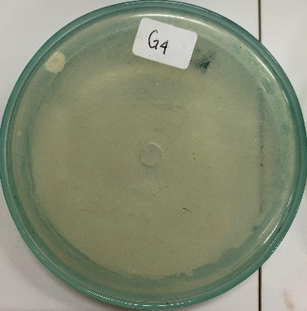
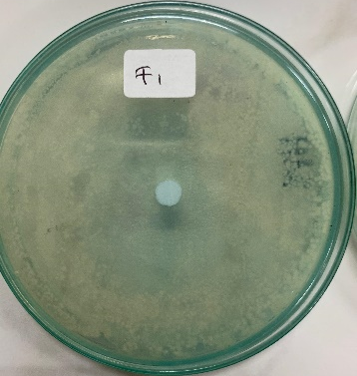
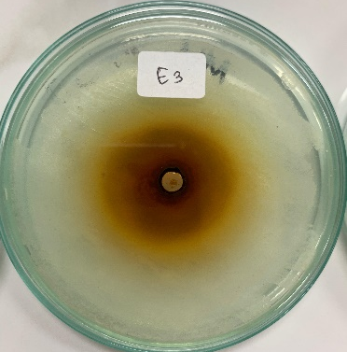
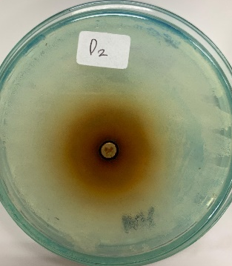
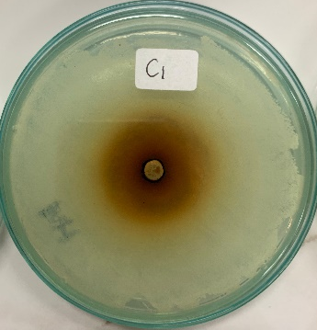
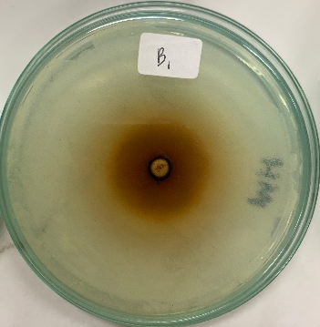
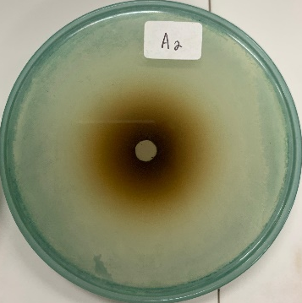
A
B
C
D
G
F
E
Source: Results of 2024
Figure 1. (A) White cempaka flower extract concentration 20%; (B) White cempaka flower extract concentration 40%; (C) White cempaka flower extract concentration 60%; (D) White cempaka flower extract with a concentration of 80%; (E) White cempaka flower extract 100% concentration. (f) Positive Control; (G) Negative control.
Table 2. Kolmogorov-Smirnov One-Sample Normality Test
Bacteria | Sig.
Corynebacterium diphtheriae | 0.200

Source: Results of 2024

Based on Table 2 above, the results of measuring the diameter of the inhibition zone have a value of p = 0.200 > 0.05, meaning that the distribution is normal in the results of measuring the diameter of the inhibition zone.
Table 3. Levene Homogeneity Test
Bacteria | Sig.
Corynebacterium diphtheriae | <0.001

Source: Results of 2024
Based on Table 3, the results of the homogeneity test are known to have a value of p = 0.001<0.05 (5% or 0.05) which means that this data is not homogeneous in terms of variation. Although the data is not homogeneous, in the normality test, normal results were obtained so that the One-Way Anova test can still be continued.
Table 4. One-Way ANOVA Test Result
Bacteria | Sig. | Identifiying
Corynebacterium diphtheriae | <0.001 | There is difference

Source: Results of 2024
Based on the results of the analysis of the One-Way Anova test, the significance value was obtained of <0.001, which is smaller than p (p=0.05), meaning that there is a significant difference between groups.
Table 5. LSD Post Hoc Test Results
(I) Concentration |  | (J) Concentration | Sig. | Identifying
20% | 40% |  | 0.207 | There is no difference
20% | 60% |  | 0.023 | There is difference
20% | 80% |  | 0.005 | There is difference
20% | 100% |  | 0.004 | There is difference
20% | K positif |  | 0.603 | There is no difference
20% | K negatif |  | 0.000 | There is difference
40% | 20% |  | 0.207 | There is no difference
40% | 60% |  | 0.264 | There is no difference
40% | 80% |  | 0.075 | There is no difference
40% | 100% |  | 0.068 | There is no difference
40% | K positif |  | 0.448 | There is no difference
40% | K negatif |  | 0.000 | There is difference
60% | 20% |  | 0.023 | There is difference
60% | 40% |  | 0.264 | There is no difference
60% | 80% |  | 0.475 | There is no difference
60% | 100% |  | 0.444 | There is no difference
60% | K positif |  | 0.069 | There is no difference
60% | K negatif |  | 0.000 | There is difference
80% | 20% |  | 0.005 | There is difference
80% | 40% |  | 0.075 | There is no difference
80% | 60% |  | 0.475 | There is no difference
80% | 100% |  | 0.959 | There is no difference
80% | K positif |  | 0.015 | There is difference
80% | K negatif |  | 0.000 | There is difference
100% | 20% |  | 0.004 | There is difference
100% | 40% |  | 0.068 | There is no difference
100% | 60% |  | 0.444 | There is no difference
100% | 80% |  | 0.959 | There is no difference
100% | K positif |  | 0.013 | There is difference
100% | K negatif |  | 0.000 | There is difference
K positive | 20% |  | 0.603 | There is no difference
K positive | 40% |  | 0.448 | There is no difference
K positive | 60% |  | 0.069 | There is no difference
K positive | 80% |  | 0.015 | There is difference
K positive | 100% |  | 0.013 | There is difference
K positive | K negatif |  | 0.000 | There is difference
K Negative | 20% |  | 0.000 | There is difference
K Negative | 40% |  | 0.000 | There is difference
K Negative | 60% |  | 0.000 | There is difference
K Negative | 80% |  | 0.000 | There is difference
K Negative | 100% |  | 0.000 | There is difference
K Negative | K positif |  | 0.000 | There is difference
Source: Results of 2024
The positive control group with erythromycin administration is significantly different from the concentration group of white cempaka flower extract (Michelia alba dc) 80%, 100% and negative control because the significance is less than 0.05. The positive control group with erythromycin administration is not significantly different from the concentration group of 20% and 40% white cempaka flower extract (Michelia alba dc) because the significance is more than 0.05. This can be interpreted that giving the concentration of white cempaka flower extract (Michelia alba dc) 100% is more effective than the concentration group of giving white cempaka flower extract (Michelia alba dc) 80%, positive control and negative control. And the positive control by giving erythromycin has the same effectiveness as the concentration group giving 20%, 40% and 60% white cempaka flower extract (Michelia alba dc).

DISCUSSION
In the media given white cempaka flower extract (Michelia alba dc) produces a clear zone that is brownish in color. The brown color created in the white cempaka flower extract is due to the compounds contained in the flower interacting with ethanol. Alkaloid, flavonoid and terpenoid compounds present in flowers after extraction interact with ethanol and form complex compounds or undergo oxidation which causes the creation of brown extracts (Rauf et al., 2023). For media treated with erythromycin antibiotics in the wells, a clear zone of white color was formed. Meanwhile, the media treated with distilled water as a negative control showed the results that no visible inhibition zone was formed.
The results of the One-Way Anova test analysis obtained a significance value of <0.001, which is smaller than p (p=0.05), which means that there is a significant difference in the effect of the treatment given to the bacteria. This shows that between the positive control and the five concentrations of white cempaka flower extract (Michelia alba dc) concentrations of 20%, 40%, 60%, 80% and 100% give different activity effects on inhibiting the growth of Corynebacterium diphtheriae bacteria. As for the negative control, it has no effect at all on Corynebacterium diphtheriae. For the antibacterial effectiveness test, the best is seen at 100% extract concentration while even the smallest concentration, 20%, can still inhibit the growth of Corynebacterium diphtheriae bacteria.
To see the difference between each treatment, using the LSD post hoc test and will be compared with the control group. The results of the LSD post hoc test are that the positive control group with erythromycin administration is significantly different from the concentration group of white cempaca flower extract (Michelia alba dc) 80%, 100% and negative control and there is no significant difference with the concentration group of white cempaca flower extract (Michelia alba dc) 20%, 40% and 60%. The negative control group is significantly different from the concentration group of white cempaca flower extract (Michelia alba dc) 20%, 40%, 60%, 80%, 100% and positive control. It can be interpreted that flowers have the ability to inhibit Corynebacterium diphtheriae bacteria. The concentration group giving white cempaka flower extract (Michelia alba dc) 100% is the most effective concentration in inhibiting the growth of Corynebacterium diphtheriae bacteria.
To determine the effectiveness of the inhibition of white cempaka flower extract (Michelia alba dc) against the growth of Corynebacterium diphtheriae bacteria by measuring the clear zone formed around the well after treatment. The clear zone itself is a description of the sensitivity of bacteria to antibacterial materials used in the test and is expressed by the width of the diameter of the inhibition zone formed (Rastina et al., 2015). Classification of bacterial growth inhibition activity is by looking at the clear zone formed which is divided into weak, medium, strong, and very strong. If the diameter formed is 5 mm or less, it is classified as weak, classified as moderate if the diameter ranges from 5-10 mm, the diameter ranges from 10-20 mm then classified into a strong response and if more than 20 mm then classified into a very strong response (Jamilatun et al., 2020). Based on this classification, it can be stated that in all treatments with the administration of white cempaka flower extract (Michelia alba dc) concentrations of 20%, 40%, 60%, 80%, 100% and the provision of positive control using erythromycin is classified in the very strong category. This indicates that the response or effect produced by all treatments has a very high level of strength or significance in the tests carried out.
The results showed that the concentration of white cempaka flower extract (Michelia alba dc) 100% showed the greatest average inhibition zone of 54.69mm including in the class of very strong response with a standard deviation of 2.66mm, 80% concentration in second place which formed an inhibition zone of 54.49mm with a standard deviation of 2.89mm, then followed by white cempaka flower extract (Michelia alba dc) 60% concentration with an inhibition zone of 51.66mm with a standard deviation of 1.60mm and white cempaka flower extract (Michelia alba dc) 40% concentration with an inhibition zone of 47.21mm with a standard deviation of 3.53mm. The concentration of 20% standard deviation of 4.80mm with an inhibition zone of 42.16mm is the smallest inhibition zone result compared to the positive control, which is giving treatment to bacteria using erythromycin. The inhibition formed from the positive control is 44.21mm standard deviation 12.63mm. In this case, the larger inhibition zone indicates the ability of the extract to inhibit bacterial growth more effectively than the antibiotic erythromycin. The size of the zone of inhibition and standard deviation give an idea of the antibacterial effectiveness of the extract, but do not provide direct information regarding its toxicity. To assess whether the extract is toxic, more in-depth research and safety tests are needed, one of which is in vivo or using experimental animals (Wuri et al., 2021).
In the treatment given to Corynebacterium diphtheriae bacteria by giving white cempaka flower extract (Michelia alba dc) has very strong antibacterial activity. The results of the treatment showed that the higher the concentration given, the greater the inhibition zone created around the well. This is in accordance with research conducted by Magvirah et al., (2019) found that the higher the concentration of extracts against bacterial growth, the greater the inhibition zone formed. The formation of inhibition zones that have a large diameter is in line with the statement that at higher concentrations there are more antibacterial substances. In this study using the well method, each hole is filled with a concentration of extract. This method is done to make the osmolarity more thorough and homogeneous. This method also produces a larger and stronger concentration of extract to stop bacterial growth. Using this pitting method is easier to measure the results of the inhibition zone formed because bacterial isolates will form to the bottom (Haryati et al., 2017). This method using wells has advantages in antibacterial testing, which will create higher antibacterial activity compared to using the disc method (Nurhayati et al., 2020).
The results of the study for the antibacterial inhibition zone using the positive control of erythromycin antibiotics formed an average inhibition zone diameter of 44.21mm. According to research by Mutahhar et al., (2020) which aims to determine antibacterial activity against Corynebacterium diphtheriae by observing its sensitivity pattern using the Epsilometer test (Etest) as a diffusion technique. From the results of this study, it was found that Erythromycin has strong antibacterial activity against Corynebacterium diphtheriae bacteria, namely the results showed that 90% were classified as sensitive and 10% were classified as moderate. Erythromycin is classified as a macrolide antibiotic which is very commonly used for the treatment of gram-positive bacteria. Research conducted by Benamrouche et al., (2016) using 157 isolates of Corynebacterium diphtheriae. The results obtained from the study were 157 isolates used were susceptible to erythromycin antibiotics.
Corynebacterium diphtheriae belongs to the group of Gram-positive bacteria. This group of bacteria is characterized by a layer of teichoic acid covering the peptidoglycan and in many aspects is functionally equivalent to the outer membrane of Gram-negative bacteria. In Gram-positive bacteria, the cell is created from an array of PG (petidoglycan) so that the cell wall is rigid (Ott et al., 2017). A water-soluble polymer has a function as a positive ion transport in order to get in and out of the substance. Gram-positive bacterial cell walls have more polar properties because of these soluble properties. White cempaka flower (Michelia alba dc) contains compounds that are polar. therefore, it can more easily enter through the peptidoglycan layer which has polar properties in the bacterial cell wall. Antibacterial molecules that enter will increase the osmotic pressure inside the cell, thus increasing the risk of lysis (Audies, 2015).
According to research conducted by Khairan et al., (2021) which shows that white cempaka flower extract contains alkaloid, steroid, terpenoid, saponin, flavonoid and phenol compounds. Flavonoid, alkaloid and phenol compounds are known as secondary metabolites that inhibit bacteria through the cell wall so that later suppress the growth of bacteria so as not to grow more (Rahmawati, 2020). Flavonoid compounds have an antibacterial mechanism to inhibit cell membrane function by forming complex materials consisting of extracellular and soluble proteins so that they can damage the bacterial cell membrane. In addition, flavonoids directly affect the microbial cell cycle by stopping the cell activity of microorganisms (Septiani et al., 2017).
Another polar compound is alkaloid. Alkaloids work by disrupting the constituent parts of peptidoglycan in bacterial cells, so that the formation of bacterial cell walls fails to form completely (Budianto N. et. al., 2023). In addition, phenol has antibacterial activity because it interacts with bacterial cells through an absorption process that involves the formation of Hydrogen bonds (Ayuningtyas, 2018). The arrangement of phenol in the lipid bilayer can affect lipid-protein interactions and cause high membrane permeability. This in turn changes the membrane structure and accelerates the leakage of intracellular constituents, which ultimately destroys the integrity of the membrane (Wu et al., 2016).
White cempaka flowers also contain terpenoid compounds that can carry out antibacterial mechanisms. Terpenoid compounds are classified into non-polar compounds (Budianto, 2020). The mechanism of action of terpenoids has the ability to react with transmembrane proteins located on the outer membrane of the bacterial cell wall. This mechanism produces strong polymer bonds resulting in porin damage. The damage of porin, which has a function as the entrance and exit of the compound, will make the bacterial cell wall less permeable. This results in bacterial cells becoming deprived of nutrients, and will die because their growth is inhibited (Nugroho et al., 2015). Fresh cempaka flowers contain volatile compounds such as a-myrcene, (S)-limonene, (R)-fenchone, linalool, camphor, caryophyllene, and germacrene. These compounds are classified as terpenoids. α-Myrcene, (S)-Limonene, Linalool, Germacrene, Caryophyllene and Camphor can disrupt the integrity of bacterial cell membranes, cause leakage of ions and small molecules, and disrupt membrane functions that are important for bacterial survival (Wang et al., 2020).
Steroids have antibacterial properties by showing a mechanism in which steroids specifically associate with membrane lipids so that they can cause leakage from liposomes (Mulay and Shinde, 2016). Furthermore, there are saponin compounds, which are included in compounds that interfere with the activity of the bacterial wall. Finally, saponins have a content called AKP (alkaline phosphatase), which can result in the lysis of the cell wall of bacteria. This can occur because the content soars rapidly when additional saponins are added to the bacterial culture (Khan et al., 2018).
This study is also in accordance with research that has been conducted on white cempaka flower extract (Michelia alba dc). Munira et al., (2021) proved that the natural antibacterial ability of white cempaka flowers against pathogenic bacteria, namely Propionibacterium acnes. The inhibition formed from the methanol extract of white cempaka flowers (Michelia alba dc) has the largest diameter against bacterial growth with an extract concentration of 8% (9.6 mm), which is classified as a moderate response. In this study it was also found that white cempaka flower (Michelia alba dc) with the largest concentration of 100% is the most effective concentration in inhibiting the growth of Corynebacterium diphtheriae bacteria because it produces the largest inhibition zone compared to other concentrations and is classified as a very strong response.

CONCLUSION
The conclusion of the research was that white cempaka flower extract (Michelia alba dc) in concentrations (20%, 40%, 60%, 80%, and 100%) had antibacterial effectiveness against the growth of Corynebacterium diphtheriae and at a concentration of 100% it is the most effective concentration in inhibiting the growth of Corynebacterium diphtheriae bacteria because it produces the largest inhibition zone compared to other concentrations and is classified as a very strong response.

CONFLICT OF INTEREST
The authors declare that they have no conflict of interest.

ACKNOWLEDGEMENTS
We would like to express our deepest gratitude to Wijaya Kusuma Surabaya University, especially the microbiology laboratory, for their invaluable support and contribution to this research.

REFERENCES
Alawiyah, T. (2019). Analisis Hubungan Status Imunisasi & Lingkungan Fisik Rumah dengan Kejadian Difteri pada Umur 15 Tahun Keatas. Jurnal Unsil, 53(9), 1689–1699.
Audies A. (2015). Uji Efektivitas Antibakteri Ekstrak Kulit Nanas (Ananas Comosus. L) Terhadap Pertumbuhan Streptococcus Mutans Penyebab Karies Gigi. Ekp, 13, 113–121.
Ayuningtyas, A. (2018). Penetapan Kadae Fenolat Total Dalam Ekstrak Etanol Rumput Laut Coklat (Sargassum sp.) Daerah Banten, Garut & Kepulauan Seribu Secara Spektrofotometri Cahaya Tampak. Skripsi, (2018), 5–13.
Batubara, I., & Prastya, ME. (2020). Potensi Tanaman Rempah & Obat Tradisional Indonesia Sebagai Sumber Bahan Pangan Fungsional. Seminar Nasional Lahan Suboptimal Ke-8 Tahun (2020), October, 24–38.
Benamrouche, N., Hasnaoui, S., Badell, E., Guettou, B., Lazri, M., Guiso, N., & Rahal, K. (2016). Microbiological and molecular characterization of Corynebacterium diphtheriae isolated in Algeria between 1992 and (2015). Clinical Microbiology and Infection, 22(12), 1005.e1-1005.e7. https://doi.org/10.1016/j.cmi.(2016).08.013
Budianto, N. E. W. (2020). Daya Hambat & Daya Bunuh Ekstrak Serbuk Batang Siwak Terhadap Bakteri Streptococcus Pyogenes. Hang Tuah Medical Journal, 18(1), 100–113.
Budianto N. E. W, Furkani A, Budianto N.D. (2023). Analisis Pengaruh Pemberian Ekstrak Etanol Buah Rambusa (Passiflora foetida L.) Terhadap Zona Hambat Pertumbuhan Bakteri Escherichia coli. Journal of Herbal, Clinical and Pharmaceutical Science (HERCLIPS), 5(01), 48. https://doi.org/10.30587/herclips.v5i01.6205
Dekotyanti, T. (2022). Efektifitas Antibiotik Eritromicin Terhadap Bakteri Propionibacterium Acnes Dengan Metode Difusi Pada Acne Vulgaris. Molucca Medica, 15(1), 74–83. https://doi.org/10.30598/molmed.(2022).v15.i1.74
Haryati, SD., Darmawati, S., & Wilson, W. (2017). Perbandingan Efek Ekstrak Buah Alpukat (Persea americana Mill) terhadap Pertumbuhan Bakteri Pseudomonas aeruginosa dengan Metode Disk & Sumuran. Prosiding Seminar Nasional Publikasi Hasil-Hasil Penelitian & Pengabdian Masyarakat “Implementasi Penelitian & Pengabdian Masyarakat Untuk Peningkatan Kekayaan Intelektual,” September, 348–352.
Heirina, A., Rozirwan, R., & Hendri, M. (2020). Isolasi & aktivitas antibakteri jamur endofit pada mangrove Sonneratia alba dari Tanjung Carat Kabupaten Banyuasin Sumatera Selatan. Jurnal Penelitian Sains, 22(1), 16. https://doi.org/10.56064/jps.v22i1.562https://doi.org/10.56064/jps.v22i1.562
Jamilatun, M., Aminah, A., & Shufiyani, S. (2020). Uji Daya Hambat Antibakteri Kapang Endofit Dari Tanaman Alang-Alang (Imperata Cylindrica (L.) Beauv.) Terhadap Pertumbuhan Bakteri Staphylococcus Aureus & Escherichia Coli. Jurnal Medikes (Media Informasi Kesehatan), 7(2), 335–346. https://doi.org/10.36743/medikes.v7i2.224
Kementrian Kesehatan Republik Indonesia. (2017). Farmakope Herbal Indonesia. Kementrian Kesehatan Republik Indonesia. https://doi.org/10.2307/jj.2430657.12
Khairan, K., Septiya, S., & Murniana. (2021). Antibacterial activity of Magnolia alba flower extracts on Staphylococcus epidermidis and Staphylococcus aureus. IOP Conference Series: Earth and Environmental Science, 711(1). https://doi.org/10.1088/1755-1315/711/1/01(2017)
Khan, MI., Ahhmed, A., Shin, JH., Baek, JS., Kim, MY., & Kim, JD. (2018). Green Tea Seed Isolated Saponins Exerts Antibacterial Effects against Various Strains of Gram Positive and Gram Negative Bacteria, a Comprehensive Study in Vitro and in Vivo. Evidence-Based Complementary and Alternative Medicine, (2018). https://doi.org/10.1155/(2018)/3486106
Maesaroh, S., & Özel, ÇA. (2021). Biotechnological Approaches for the Improvement of Magnolia Genus Grown in Indonesia. Osmaniye Korkut Ata Üniversitesi Fen Bilimleri Enstitüsü Dergisi, 4(2), 186–203. https://doi.org/10.47495/okufbed.825177
Magvirah, T., Marwati, & Ardhani, F. (2019). Uji Daya Hambat Bakteri Staphylococcus aureus Menggunakan Ekstrak Daun Tahongai (Kleinhovia hospita L.). Jurnal Peternakan Lingkungan Tropis, 2(2), 41–50.
Mulay, Y., & Shinde, AB. (2016). Phytochemical Analysis and Antibacterial Properties of Some Selected Indian Medicinal Plants, Original Research Article.
Munira, S., Nasution, R., Saidi, N., Bahi, M., & Marianne, M. (2021). Crude extracts of Magnolia alba flowers using n-hexane and methanol solvents and their anti-acne potential. Journal of Medical Pharmaceutical and Allied Sciences, 10(6), 3789–3793. https://doi.org/10.22270/jmpas.V10I6.1607
Mutahhar, A., Puspitasari, D., Husada, D., Kartina, L., Basuki, P. S., & Moejito, I. (2020). Sensitivity of Erythromycin Against Toxigenic Strain of Corynebacterium diphtheriae. Indonesian Journal of Tropical and Infectious Disease, 8(1), 24–28.
Nurhayati, LS., Yahdiyani, N., & Hidayatulloh, A. (2020). Perbandingan Pengujian Aktivitas Antibakteri Starter Yogurt dengan Metode Difusi Sumuran & Metode Difusi Cakram. Jurnal Teknologi Hasil Peternakan, 1(2), 41. https://doi.org/10.24198/jthp.v1i2.27537
Ott, L., Hacker, E., Kunert, T., Karrington, I., Etschel, P., Lang, R., Wiesmann, V., Wittenberg, T., Singh, A., Varela, C., Bhatt, A., Sangal, V., & Burkovski, A. (2017). Analysis of Corynebacterium diphtheriae macrophage interaction: Dispensability of corynomycolic acids for inhibition of phagolysosome maturation and identification of a new gene involved in synthesis of the corynomycolic acid layer. PLoS one, 12(7), 1–24. https://doi.org/10.1371/journal.pone.0180105
Putra, MRE. (2019). Diagnosis & Tatalaksana Difteri. Jurnal Medika Utama, 45 02(01), 402–406.
Rahayu, DE. (2018). Efek Antimikroba Daun Sirih Merah (Piper Crocatum) Terhadap Pertumbuhan Bakteri Corynebacterium diphtheriae & Corynebacterium striatum Secara In Vitro. Skripsi, 1(1), 8.
Rahayu, N., Sa’diyah, L., & K, G. G. (2019). Uji Aktivitas Ektrak Infusa Bunga Telang (Clitoria ternatea L) Terhadap Daya Hambat Candida albicans. Repository Akademi Farmasi Surabaya 1–10.
Rahmawati, HN. (2020). Peranan Antibacterial Dalam Menghambat Pertumbuhan Bakteri Escherichia coli & Staphylococcus aureus. Pendidikan Fisika, Universitas Negeri Jakarta. 1302619030, 1–9.
Rastina, Sudarwanto, M., & Wientarsih, I. (2015). Antibacterial Activity of Ethanol Extract of Curry Leaf (Murraya koenigii) on Staphylococcus aureus, Escherichia coli, and Pseudomonas Sp. Jurnal Kedokteran Hewan, 9(2), 185–188.
Rauf, A. A., Himaniarwati, & Saranani, S. (2023). Penetapan Kadar Polifenol Total & Tanin Total Dari Ekstrak Etanol Buah Senggani (Melastoma malabathricum L.) Serta Uji Aktivitas Antioksi& Dengan Metode ABTS. Jurnal Pharmacia Mandala Waluya, 2(6), 295–304. https://doi.org/10.54883/jpmw.v2i6.40
Safrina. 2022. Uji aktvitas antimicrobial dan kandungan senyawa kimia bunga Cempaka Putih (Michelia alba dc). Jurnal Ilmiah Guru Madrasah (JIGM), 1(2), 83–96
Septiani, S., Dewi, EN., dan Wijayanti, I. 2017. Aktivitas Antibakteri Ekstrak Lamun (Cymodocea rotundata) Terhadap Bakteri Staphylococcus aureus dan Escherichia coli. Saintek Perikanan : Indonesian Journal of Fisheries Science and Technology, 13(1), 1. https://doi.org/10.14710/ijfst.13.1.1-6 46
Wang, L., Zhang, K., Zhang, K., Zhang, J., Fu, J., Li, J., Wang, G., Qiu, Z., Wang, X., & Li, J. (2020). Antibacterial Activity of Cinnamomum camphora Essential Oil on Escherichia coli During Planktonic Growth and Biofilm Formation. Frontiers in Microbiology, 11, 561002. https://doi.org/10.3389/FMICB.(2020).561002/FULL
Wu, Y., Bai, J., Zhong, K., Huang, Y., Qi, H., Jiang, Y., & Gao, H. (2016). Antibacterial activity and membrane-disruptive mechanism of 3-p-trans-coumaroyl-2-hydroxyquinic acid, a novel phenolic compound from pine needles of Cedrus deodara, against Staphylococcus aureus. Molecules, 21(8). https://doi.org/10.3390/molecules21081084

Wuri, R., Rosdianto, A. M., & Goenawan, H. (2021). Utilization of Rats As Blunt Trauma Animals Model: a Literature Review. Indonesia Medicus Veterinus, 10(2), 338–354. https://doi.org/10.19087/imv.(2021).10.2.338

