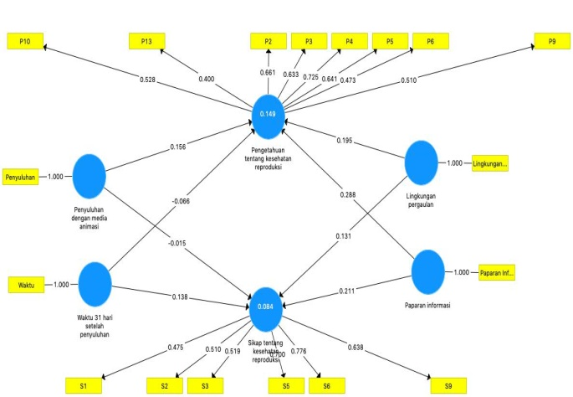
Figure 1 Final Path Chart along with Factor Loading Values after Elimination of Phase 2 Indicators

Table 1 History of Menstruation in Female Students and Wet Dreams in Male Students
 | Already | Not Yet | Total
Already got a wet dream | 38 | 47 | 85 male student
Already got menstruation | 38 | 57 | 95 female student

Table 2 History of dating and being attracted to the opposite sex
 | Yes | No | Total
Dating history | 71 | 109 | 180
Being attracted to the opposite sex | 90 | 90 | 180

Table 3 Correlations between Variables
 | Knowledge of reproductive health | Attitudes about reproductive health
Social environment | 0,195 | 0,131
Information exposure | 0,288 | 0,211
Counseling with animation media | 0,156 | -0,015
31 days after counseling | -0,066 | 0,138

Table 4 Calculation Results Using Bootstrapping
 | Standard Deviation | T Statistics | P Values
Social environment -> Knowledge | 0,044 | 4,451 | 0,000
Social environment -> Attitude | 0,062 | 2,109 | 0,035
Information exposure -> Knowledge | 0,037 | 7,724 | 0,000
Information exposure -> Attitude | 0,045 | 4,716 | 0,000
Counseling -> Knowledge | 0,049 | 3,157 | 0,002
Counseling -> Attitude | 0,061 | 0,251 | 0,802
31 days -> Knowledge | 0,048 | 1,372 | 0,171
Time 31 days -> Attitude | 0,064 | 2,168 | 0,031

