Transfer of copyright agreement

Dear Editor In Chief,

I/We, Nurlisa Naila Aulia declare that this article is original. The article entitled Bleeding Volume as A Predictor of Mortality in Intracerebral Hemorrhage Stroke Patients is herewith submitted for publication in Jurnal Ilmiah Kedokteran Wijaya Kusuma. It has not been published before, and it is not under consideration for publication in any other journal (s). It contains no matter that is scandalous, obscene, libelous, or otherwise contrary to law. I/We agree that copies made under these circumstances will continue to carry the copyright notice that appeared in the original published work. All authors declare that there is no conflict of interest in this article.

Sincerely,
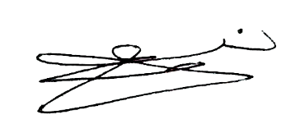
Nurlisa Naila Aulia, Neurologist
Faculty of Medicine, Universitas Nahdlatul Ulama Surabaya, Indonesia
Address: Jemursari Street No 51-57, Surabaya, Indonesia. Email: nurlisanailaaulia@unusa.ac.id. Phone Number: +6281259395353

