Sertifikat Keterengan Kelaikan Etik
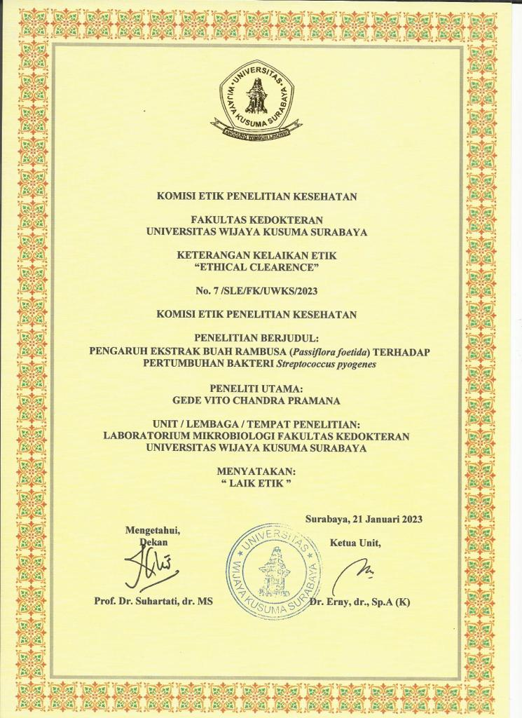
Data Mentah Hasil Penelitian
Kelompok | Diameter Zona Hambat (mm)
1 | 0
1 | 0
1 | 0
1 | 0
2 | 18.7
2 | 18.9
2 | 18
2 | 19.3
3 | 0
3 | 0
3 | 0
3 | 0
4 | 0
4 | 0
4 | 0
4 | 0
5 | 0
5 | 0
5 | 0
5 | 0
6 | 8.85
6 | 8.3
6 | 8..8
6 | 8

Dokumentasi
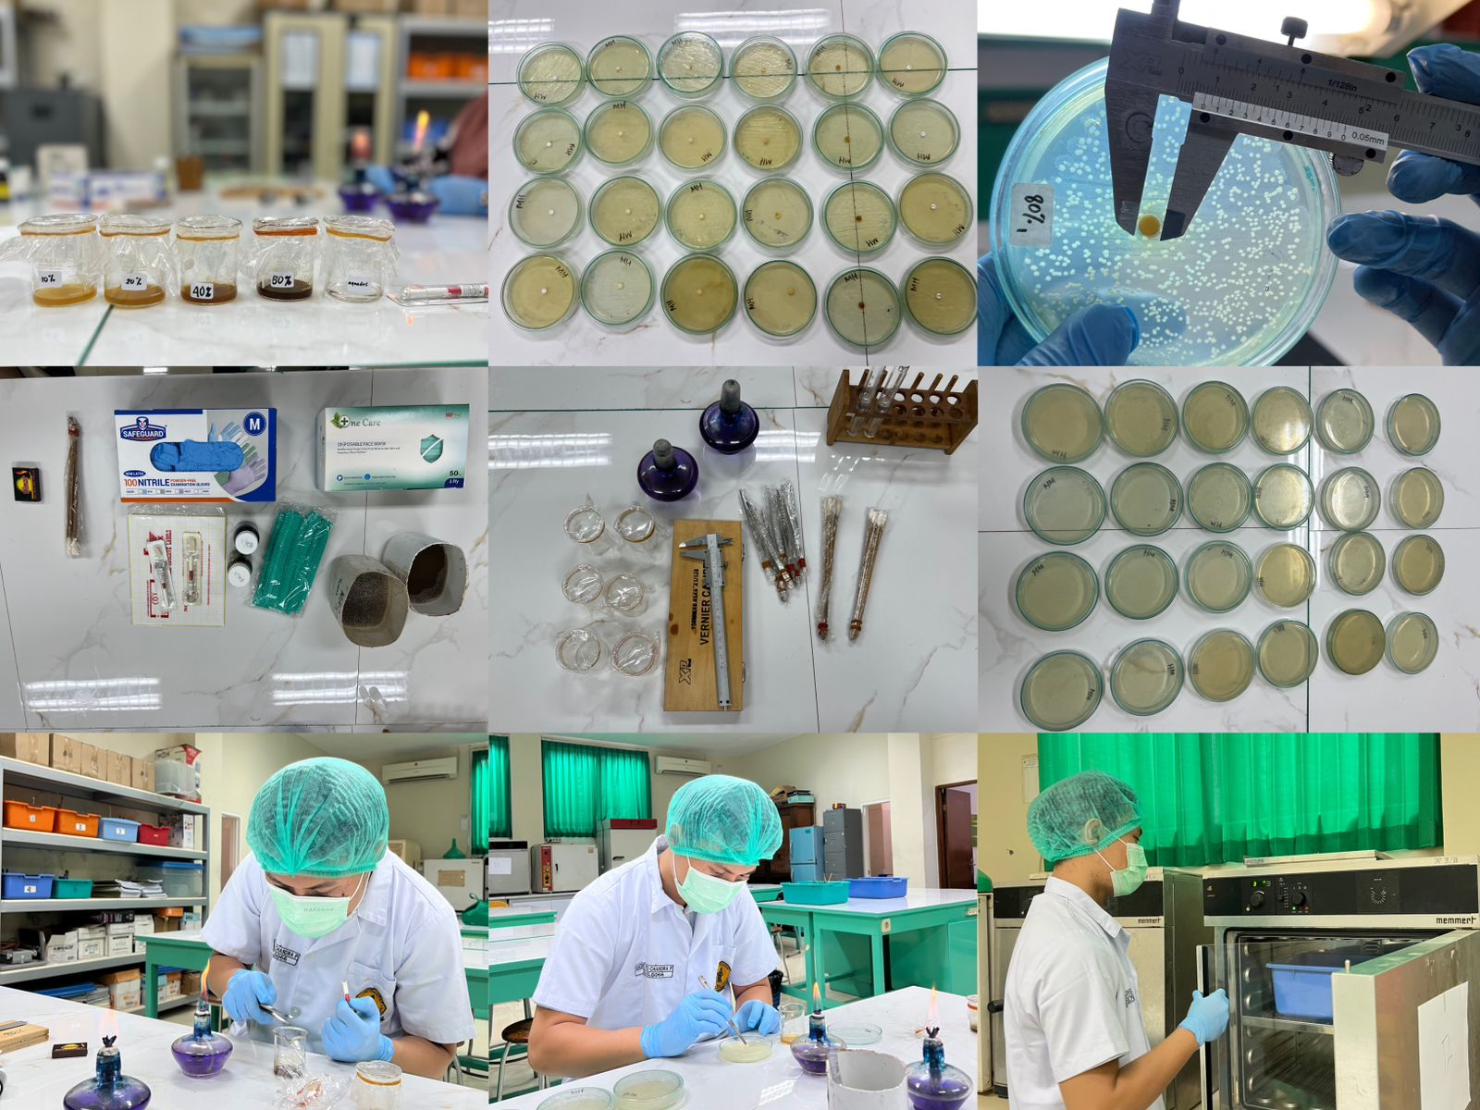

Table dan gambar
Zona hambat | N | Mean (mm) | Std. Deviation
P1 (aquades)  P2 (basitrain)  P3 (10%)  P4 (20%)  P5 (40%)  P6 (80%) | 4  4  4  4  4  4 | 0,00  18,73  0,00  0,00  0,00  8,5 | 0,00  0,54  0,00  0,00  0,00  0,41
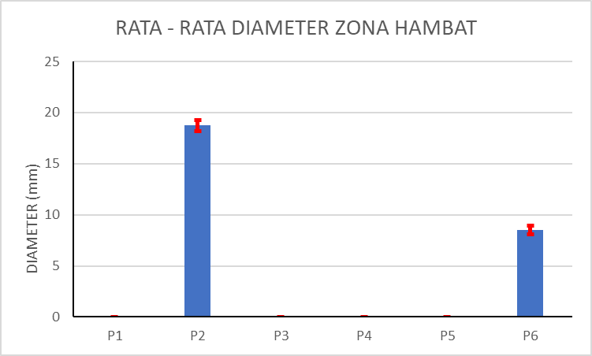
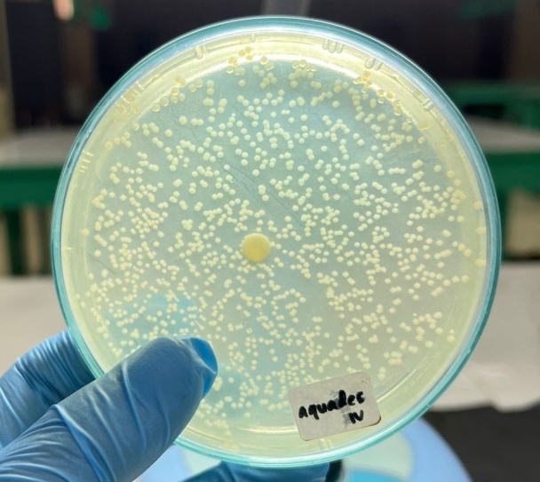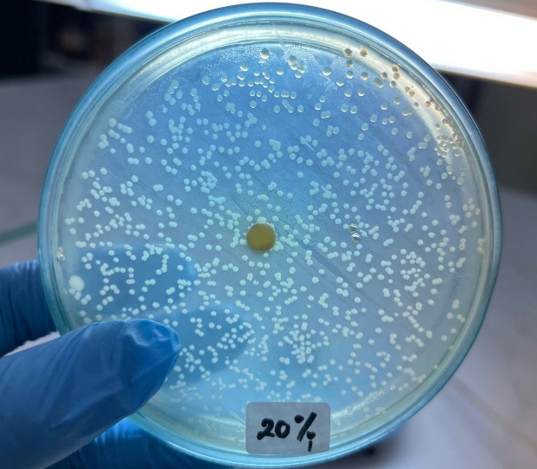
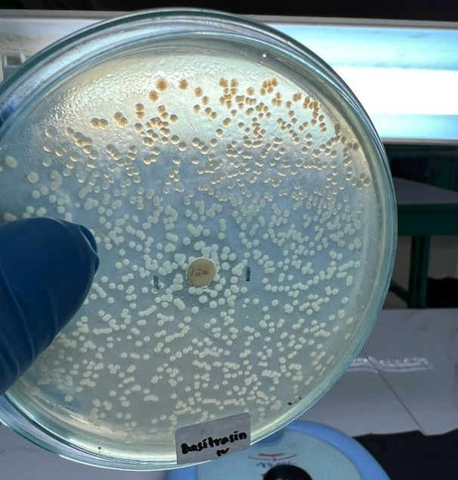
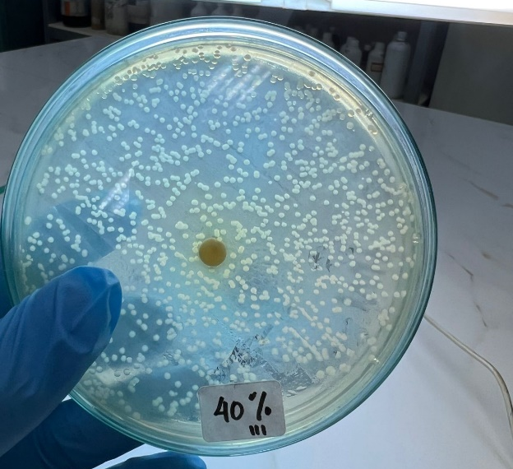
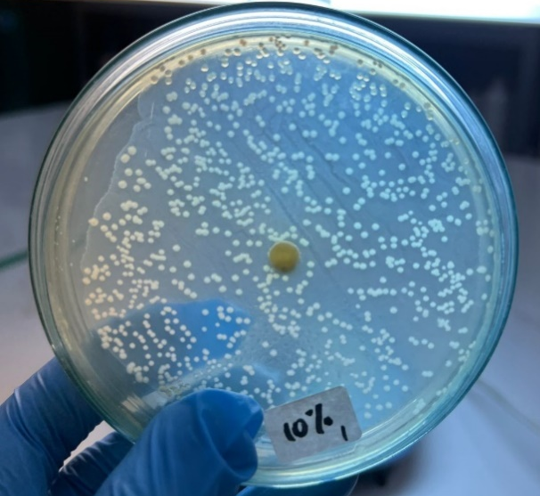
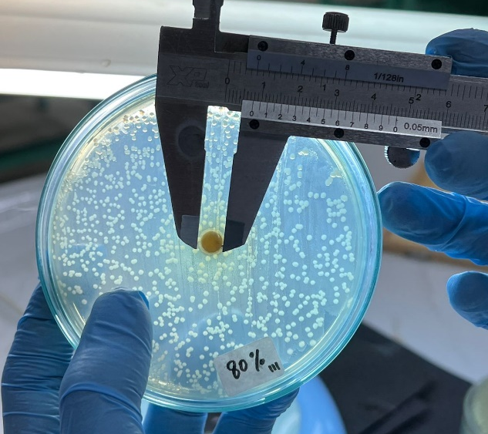

OUTPUT SPSS

NPAR TESTS
/K-S(NORMAL)=DZH
/MISSING ANALYSIS.

NPar Tests

One-Sample Kolmogorov-Smirnov Test
 |  | DZH
N |  | 24
Normal Parametersª | Mean | 4.5354
Normal Parametersª | Std. Deviation | 7.21822
Most Extreme Differences | Absolute | .402
Most Extreme Differences | Positive | .402
Most Extreme Differences | Negative | -.265
Kolmogorov-Smirnov Z |  | 1.968
Asymp. Sig. (2-tailed) |  | .001
a. Test distribution is Normal.

ONEWAY DZH BY Kelompok
/STATISTICS DESCRIPTIVES HOMOGENEITY
/MISSING ANALYSIS.

Oneway

Descriptives
DZH
 | N | Mean | Std. Deviation | Std. Error | 95% Confidence Interval for Mean |  | Minimum | Maximum
 |  |  |  |  | Lower Bound | Upper Bound | Minimum | Maximum
P1 | 4 | .0000 | .00000 | .00000 | .0000 | .0000 | .00 | .00
P2 | 4 | 18.7250 | .54391 | .27195 | 17.8595 | 19.5905 | 18.00 | 19.30
P3 | 4 | .0000 | .00000 | .00000 | .0000 | .0000 | .00 | .00
P4 | 4 | .0000 | .00000 | .00000 | .0000 | .0000 | .00 | .00
P5 | 4 | .0000 | .00000 | .00000 | .0000 | .0000 | .00 | .00
P6 | 4 | 8.4875 | .40901 | .20451 | 7.8367 | 9.1383 | 8.00 | 8.85
Total | 24 | 4.5354 | 7.21822 | 1.47341 | 1.4874 | 7.5834 | .00 | 19.30

Test of Homogeneity of Variances
DZH
Levene Statistic | df1 | df2 | Sig.
6.591 | 5 | 18 | .001

ANOVA
DZH
 | Sum of Squares | df | Mean Square | F | Sig.
Between Groups | 1196.973 | 5 | 239.395 | 3101.469 | .000
Within Groups | 1.389 | 18 | .077
Total | 1198.362 | 23

NPAR TESTS
/K-W=DZH BY Kelompok(1 6)
/MISSING ANALYSIS.

NPar Tests

Kruskal-Wallis Test

Ranks
 | Kelompok | N | Mean Rank
DZH | P1 | 4 | 8.50
DZH | P2 | 4 | 22.50
DZH | P3 | 4 | 8.50
DZH | P4 | 4 | 8.50
DZH | P5 | 4 | 8.50
DZH | P6 | 4 | 18.50
DZH | Total | 24

Test Statistics^{a,b}
 | DZH
Chi-Square | 22.716
df | 5
Asymp. Sig. | .000
a. Kruskal Wallis Test
b. Grouping Variable: Kelompok

NPAR TESTS
/M-W= DZH BY Kelompok(1 2)
/MISSING ANALYSIS.

NPar Tests

Mann-Whitney Test

Ranks
 | Kelompok | N | Mean Rank | Sum of Ranks
DZH | P1 | 4 | 2.50 | 10.00
DZH | P2 | 4 | 6.50 | 26.00
DZH | Total | 8

Test Statistics^{b}
 | DZH
Mann-Whitney U | .000
Wilcoxon W | 10.000
Z | -2.460
Asymp. Sig. (2-tailed) | .014
Exact Sig. [2*(1-tailed Sig.)] | .029ª
a. Not corrected for ties.
b. Grouping Variable: Kelompok

NPAR TESTS
/M-W= DZH BY Kelompok(1 3)
/MISSING ANALYSIS.

NPar Tests

Mann-Whitney Test

Ranks
 | Kelompok | N | Mean Rank | Sum of Ranks
DZH | P1 | 4 | 4.50 | 18.00
DZH | P3 | 4 | 4.50 | 18.00
DZH | Total | 8

Test Statistics^{b}
 | DZH
Mann-Whitney U | 8.000
Wilcoxon W | 18.000
Z | .000
Asymp. Sig. (2-tailed) | 1.000
Exact Sig. [2*(1-tailed Sig.)] | 1.000ª
a. Not corrected for ties.
b. Grouping Variable: Kelompok

NPAR TESTS
/M-W= DZH BY Kelompok(1 4)
/MISSING ANALYSIS.

NPar Tests

Mann-Whitney Test

Ranks
 | Kelompok | N | Mean Rank | Sum of Ranks
DZH | P1 | 4 | 4.50 | 18.00
DZH | P4 | 4 | 4.50 | 18.00
DZH | Total | 8

Test Statistics^{b}
 | DZH
Mann-Whitney U | 8.000
Wilcoxon W | 18.000
Z | .000
Asymp. Sig. (2-tailed) | 1.000
Exact Sig. [2*(1-tailed Sig.)] | 1.000ª
a. Not corrected for ties.
b. Grouping Variable: Kelompok

NPAR TESTS
/M-W= DZH BY Kelompok(1 5)
/MISSING ANALYSIS.

NPar Tests

Mann-Whitney Test

Ranks
 | Kelompok | N | Mean Rank | Sum of Ranks
DZH | P1 | 4 | 4.50 | 18.00
DZH | P5 | 4 | 4.50 | 18.00
DZH | Total | 8

Test Statistics^{b}
 | DZH
Mann-Whitney U | 8.000
Wilcoxon W | 18.000
Z | .000
Asymp. Sig. (2-tailed) | 1.000
Exact Sig. [2*(1-tailed Sig.)] | 1.000ª
a. Not corrected for ties.
b. Grouping Variable: Kelompok

NPAR TESTS
/M-W= DZH BY Kelompok(1 6)
/MISSING ANALYSIS.

NPar Tests

Mann-Whitney Test

Ranks
 | Kelompok | N | Mean Rank | Sum of Ranks
DZH | P1 | 4 | 2.50 | 10.00
DZH | P6 | 4 | 6.50 | 26.00
DZH | Total | 8

Test Statistics^{b}
 | DZH
Mann-Whitney U | .000
Wilcoxon W | 10.000
Z | -2.460
Asymp. Sig. (2-tailed) | .014
Exact Sig. [2*(1-tailed Sig.)] | .029ª
a. Not corrected for ties.
b. Grouping Variable: Kelompok

NPAR TESTS
/M-W= DZH BY Kelompok(2 3)
/MISSING ANALYSIS.

NPar Tests

Mann-Whitney Test

Ranks
 | Kelompok | N | Mean Rank | Sum of Ranks
DZH | P2 | 4 | 6.50 | 26.00
DZH | P3 | 4 | 2.50 | 10.00
DZH | Total | 8

Test Statistics^{b}
 | DZH
Mann-Whitney U | .000
Wilcoxon W | 10.000
Z | -2.460
Asymp. Sig. (2-tailed) | .014
Exact Sig. [2*(1-tailed Sig.)] | .029ª
a. Not corrected for ties.
b. Grouping Variable: Kelompok

NPAR TESTS
/M-W= DZH BY Kelompok(2 4)
/MISSING ANALYSIS.

NPar Tests

Mann-Whitney Test

Ranks
 | Kelompok | N | Mean Rank | Sum of Ranks
DZH | P2 | 4 | 6.50 | 26.00
DZH | P4 | 4 | 2.50 | 10.00
DZH | Total | 8

Test Statistics^{b}
 | DZH
Mann-Whitney U | .000
Wilcoxon W | 10.000
Z | -2.460
Asymp. Sig. (2-tailed) | .014
Exact Sig. [2*(1-tailed Sig.)] | .029ª
a. Not corrected for ties.
b. Grouping Variable: Kelompok

NPAR TESTS
/M-W= DZH BY Kelompok(2 5)
/MISSING ANALYSIS.

NPar Tests

Mann-Whitney Test

Ranks
 | Kelompok | N | Mean Rank | Sum of Ranks
DZH | P2 | 4 | 6.50 | 26.00
DZH | P5 | 4 | 2.50 | 10.00
DZH | Total | 8

Test Statistics^{b}
 | DZH
Mann-Whitney U | .000
Wilcoxon W | 10.000
Z | -2.460
Asymp. Sig. (2-tailed) | .014
Exact Sig. [2*(1-tailed Sig.)] | .029ª
a. Not corrected for ties.
b. Grouping Variable: Kelompok

NPAR TESTS
/M-W= DZH BY Kelompok(2 6)
/MISSING ANALYSIS.

NPar Tests

Mann-Whitney Test

Ranks
 | Kelompok | N | Mean Rank | Sum of Ranks
DZH | P2 | 4 | 6.50 | 26.00
DZH | P6 | 4 | 2.50 | 10.00
DZH | Total | 8

Test Statistics^{b}
 | DZH
Mann-Whitney U | .000
Wilcoxon W | 10.000
Z | -2.309
Asymp. Sig. (2-tailed) | .021
Exact Sig. [2*(1-tailed Sig.)] | .029ª
a. Not corrected for ties.
b. Grouping Variable: Kelompok

