Artikel Jurnal Ulos Tujung
by - -

Submission date: 19-Nov-2023 05:19PM (UTC+0200)
Submission ID: 2188826286
File name: Artikel_Jurnal_Ulos_Tujung.pdf (46.17K)
Word count: 2993
Character count: 19759
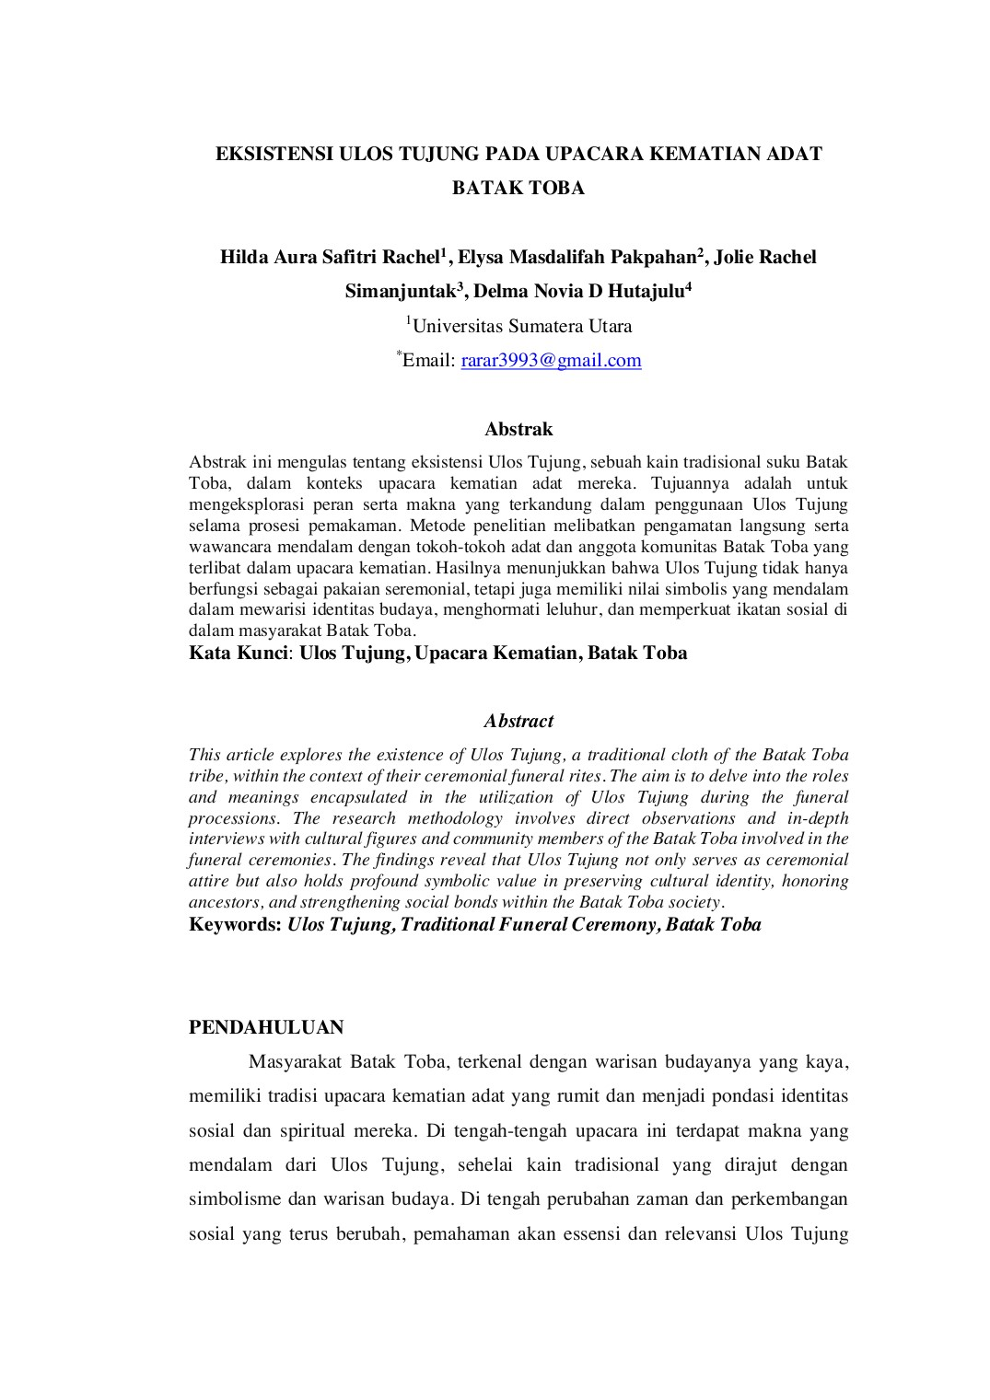
2
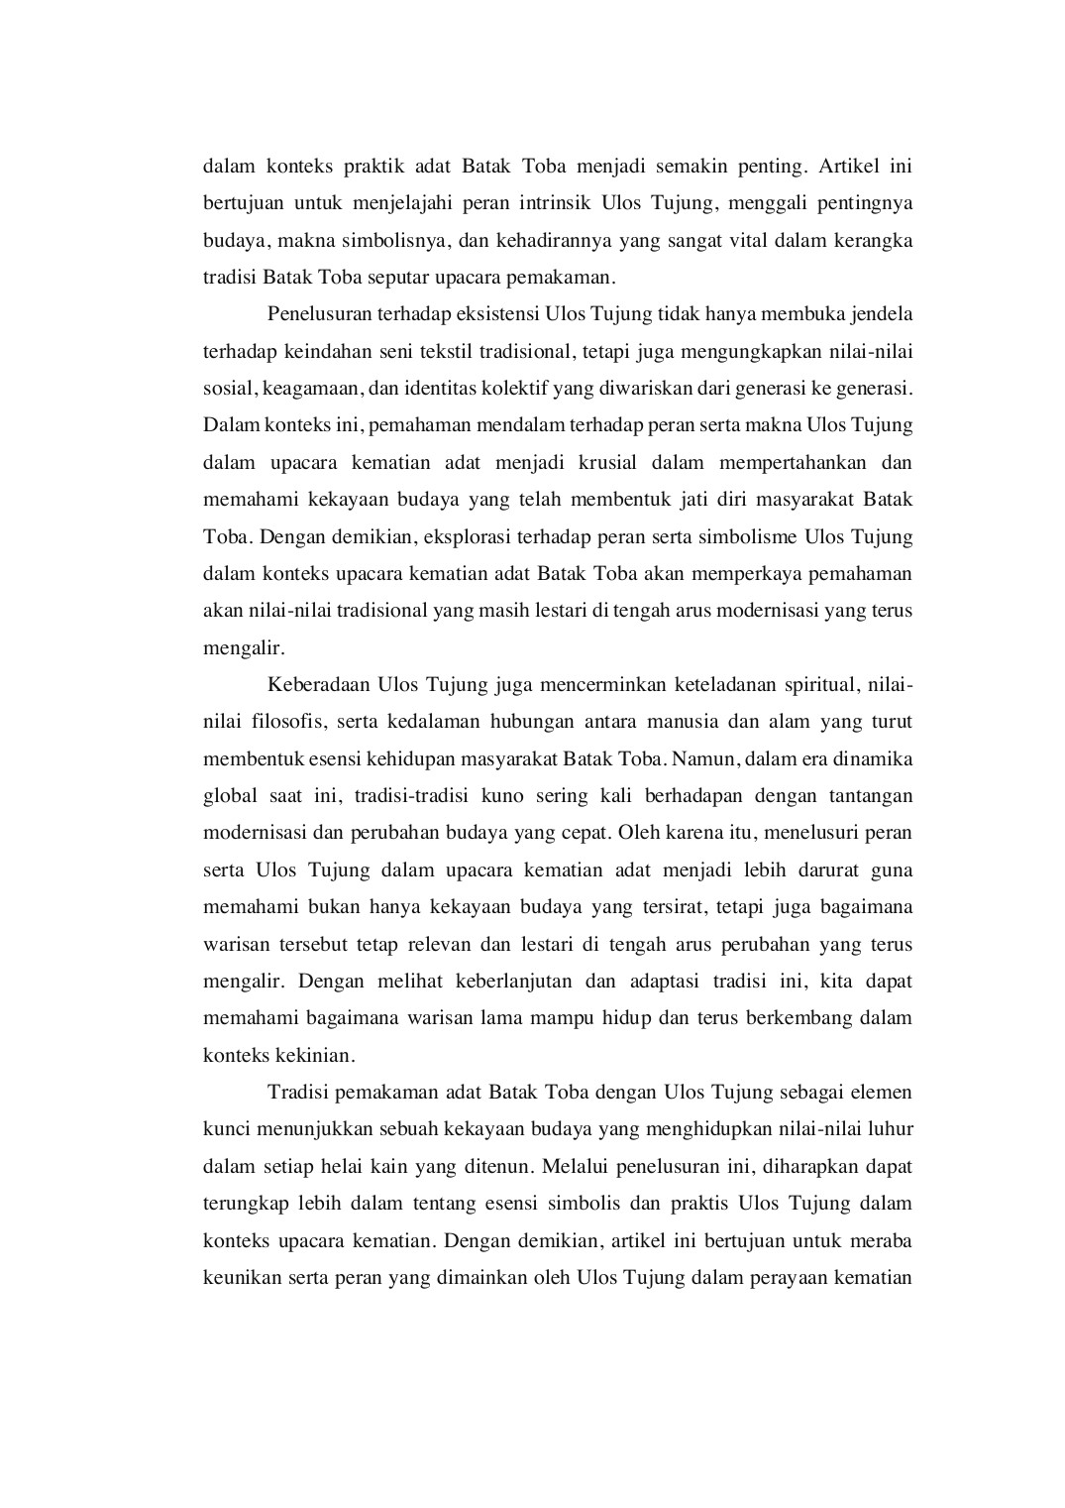
1
8
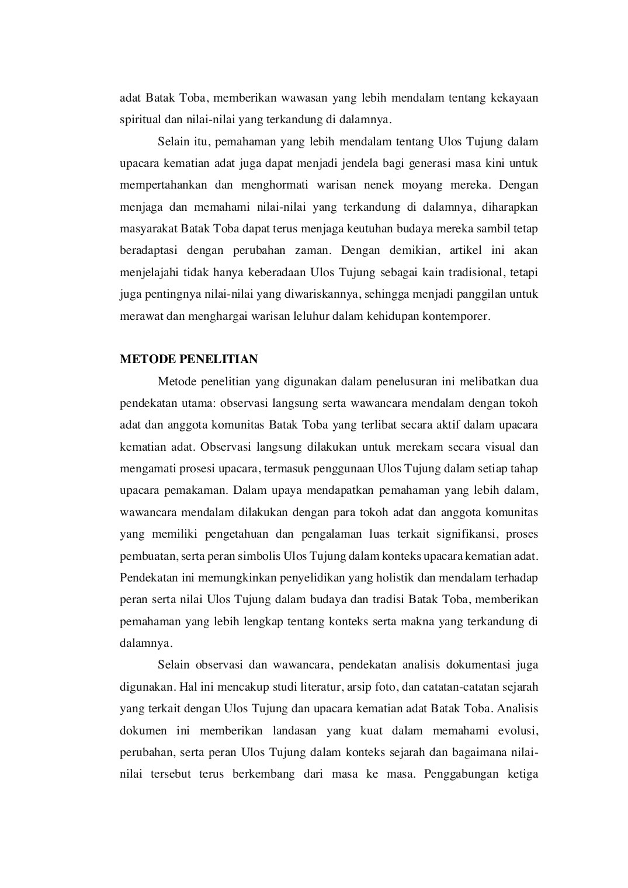
1
1
2
4
6
7

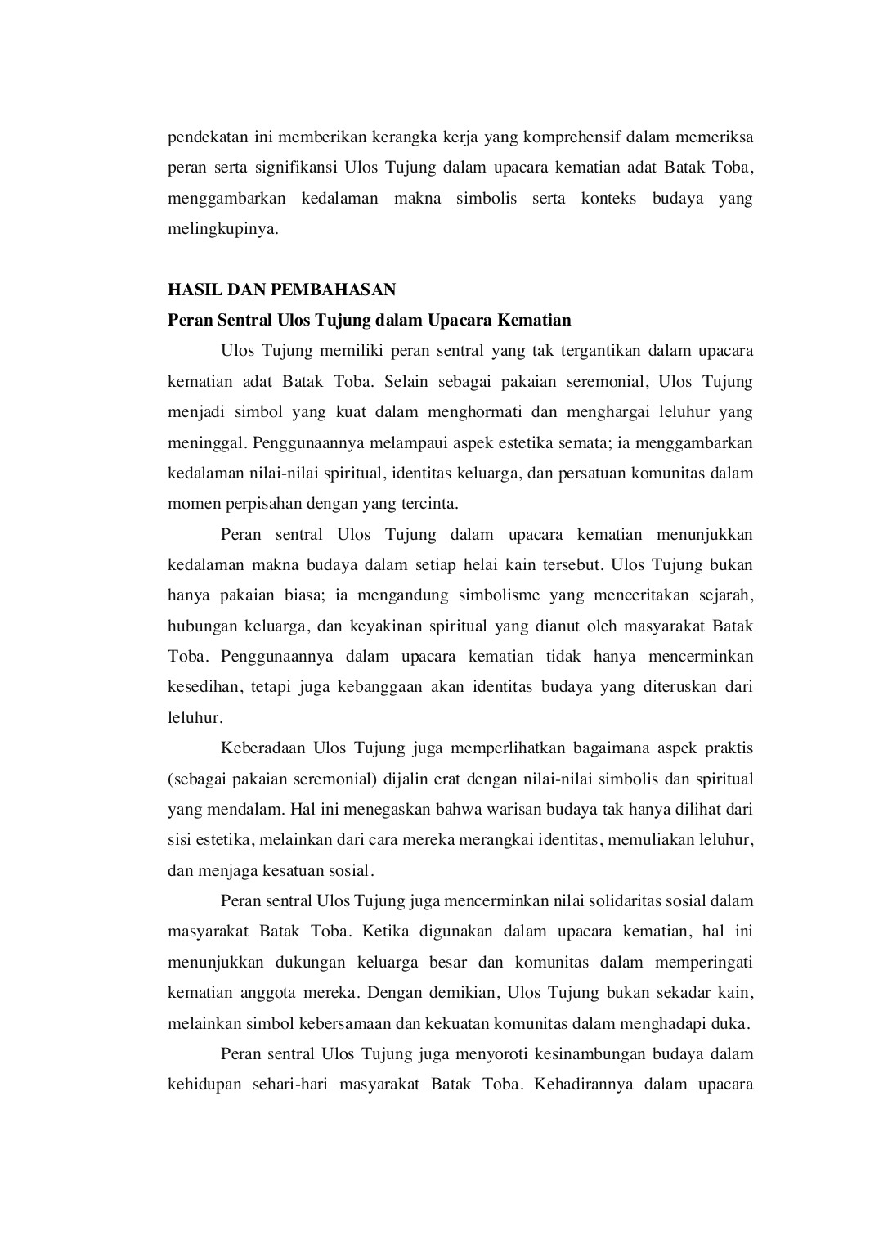
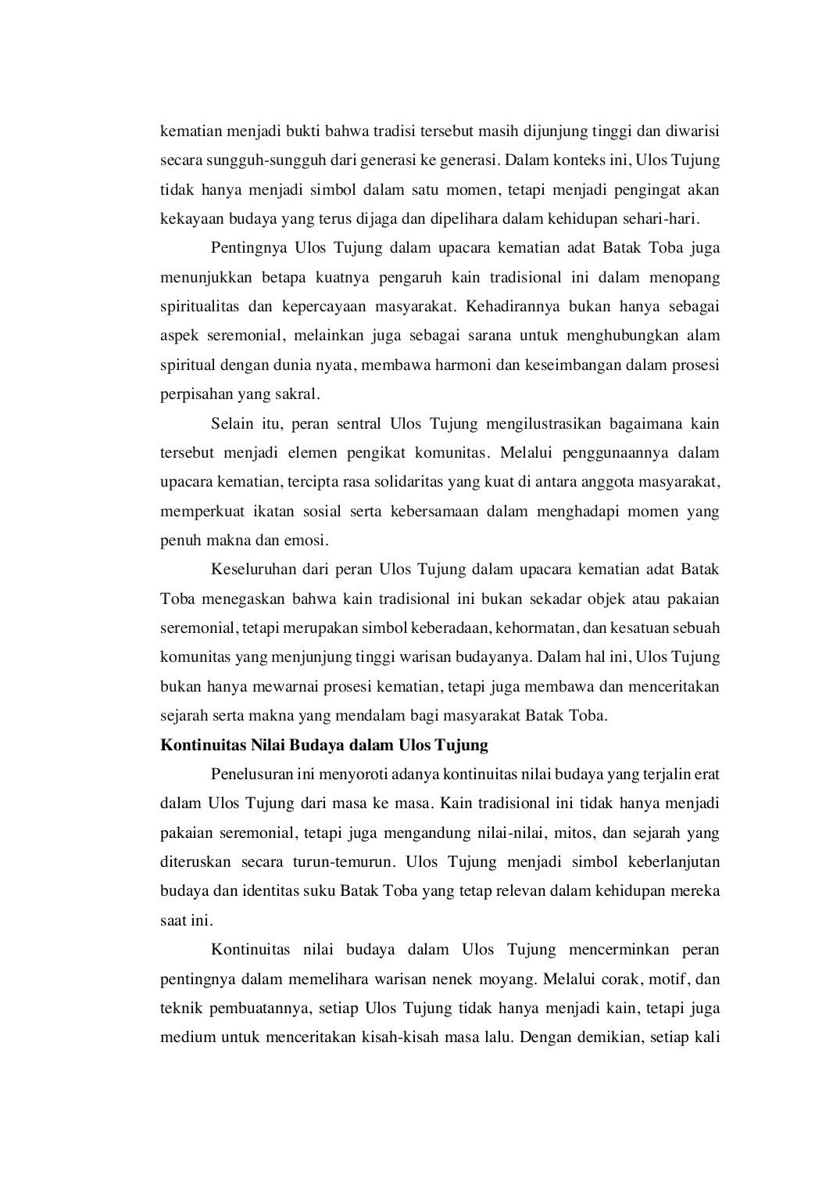

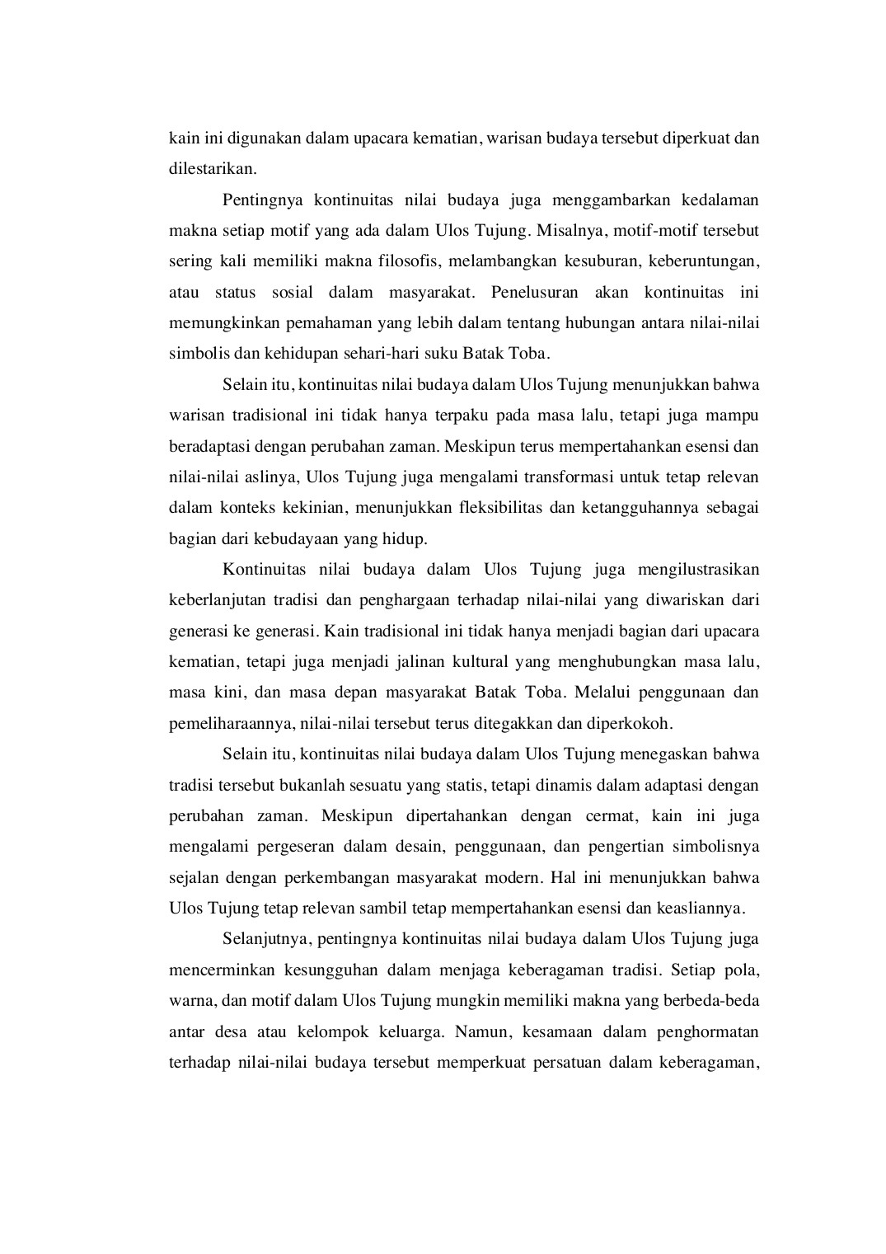
5
10

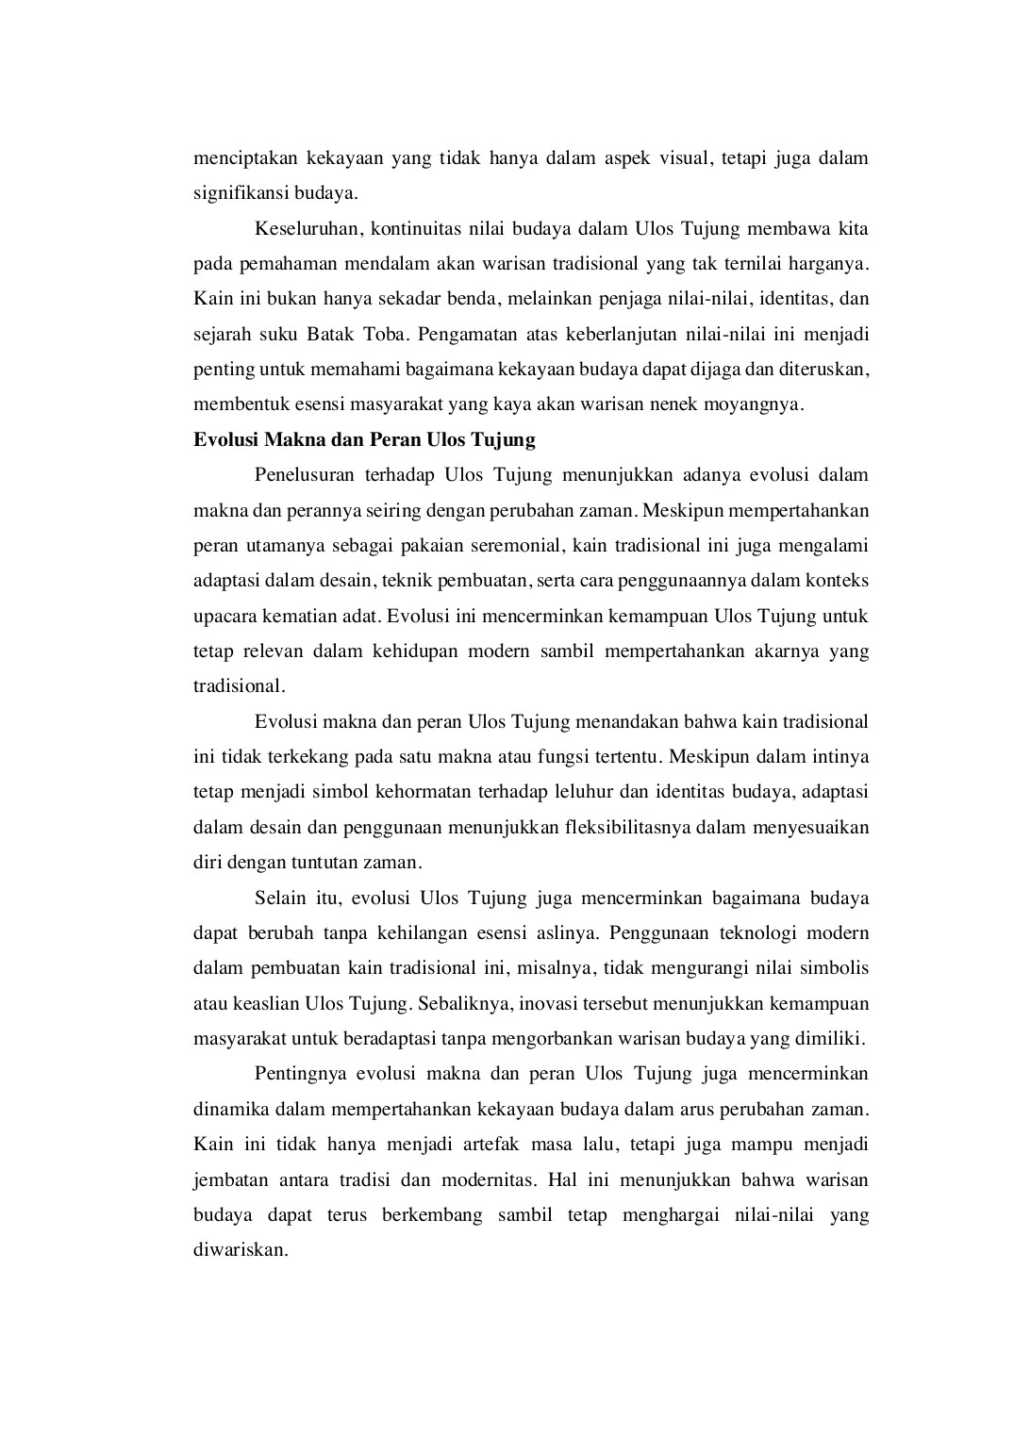

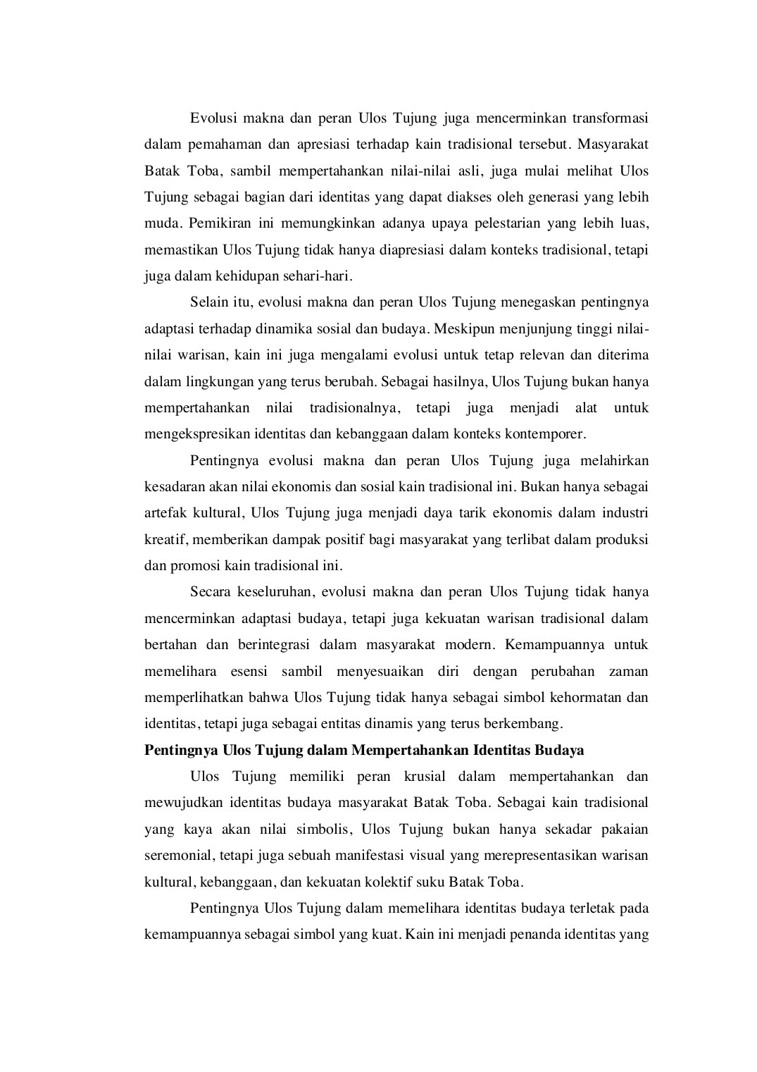
9
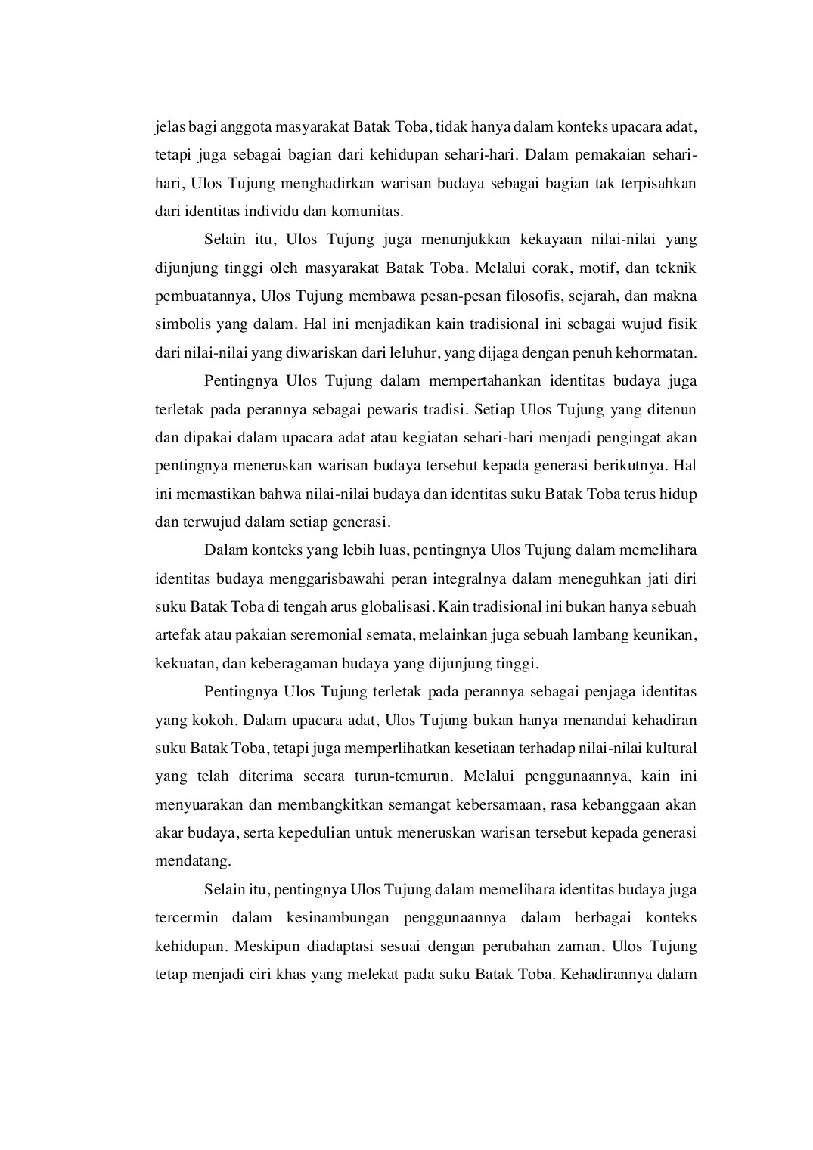
3

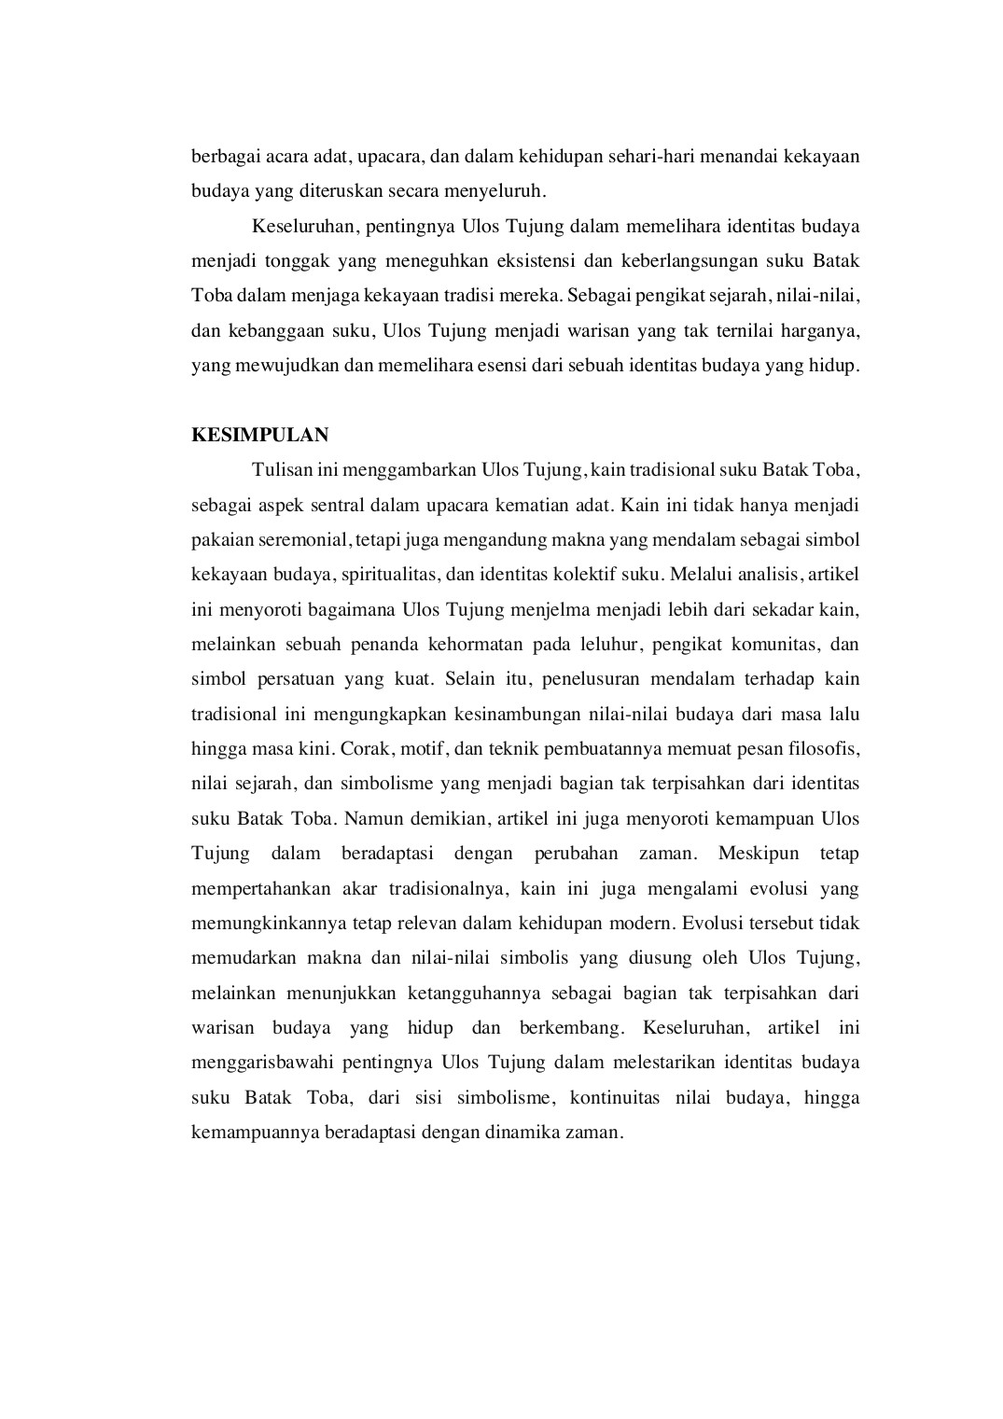
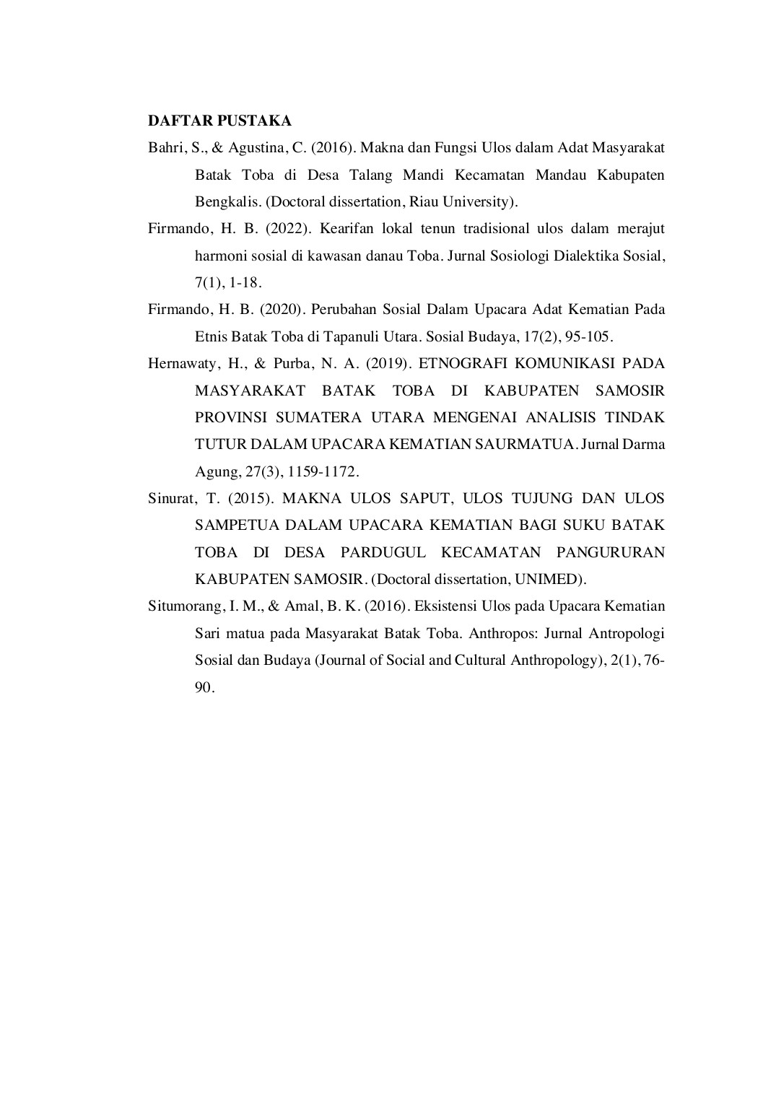

Artikel Jurnal Ulos Tujung 4% 3% 2% %

ORIGINALITY REPORT
SIMILARITY INDEX INTERNET SOURCES PUBLICATIONS STUDENT PAPERS
PRIMARY SOURCES
₁ Afdhal Afdhal. "AN EXAMINATION OF TRADITIONAL CUSTOMS IN MINANGKABAU LEADERSHIP TRADITION: CONTINUITY AND  CHANGES IN THE MODERN ERA", PUBLICUS : JURNAL ADMINISTRASI PUBLIK, 2023  Publication | 1%
2 123_{Internet Source}dok.com | 1%
3 ejournal.stftws.ac.idInternet Source | <1%
4 jurnal.unimed.ac.idInternet Source | <1%
5 ^{samsudinsahabi.wordpress.com}Internet Source | <1%
6 ^{www.indonesiamediacenter.com}Internet Source | <1%
7 core.ac.uk_{Internet Source} | <1%
8 fr.scribd.comInternet Source

<1%
9 www.researchgate.netInternet Source | <1%
10 www.scribd.comInternet Source | <1%

Exclude quotes Off Exclude matches Off
Exclude bibliography On

Artikel Jurnal Ulos Tujung

PAGE 1

PAGE 2

PAGE 3

PAGE 4

PAGE 5

PAGE 6

PAGE 7

PAGE 8

PAGE 9

PAGE 10

PAGE 11

