Lampiran Tabulasi Data Hasil Pernyataan Variabel
Pendapatan  (Y) | Modal  (X1) | Harga  (X2) | Tenaga Kerja  (X3) | Luas lahan  (X4) | Jumlah Produksi  (X5)
Total | Total | Total | Total | Total | Total
22 | 18 | 14 | 23 | 21 | 13
26 | 18 | 17 | 30 | 22 | 17
22 | 19 | 17 | 27 | 22 | 19
28 | 18 | 20 | 30 | 21 | 20
19 | 20 | 15 | 25 | 21 | 14
21 | 19 | 13 | 23 | 22 | 20
20 | 18 | 12 | 18 | 17 | 15
22 | 17 | 15 | 20 | 20 | 15
21 | 19 | 13 | 19 | 20 | 15
23 | 19 | 14 | 22 | 20 | 16
28 | 18 | 17 | 30 | 25 | 20
24 | 20 | 17 | 30 | 22 | 20
20 | 18 | 13 | 23 | 19 | 14
19 | 18 | 16 | 20 | 21 | 14
19 | 20 | 15 | 21 | 20 | 14
22 | 20 | 15 | 24 | 20 | 16
20 | 19 | 14 | 22 | 21 | 15
21 | 20 | 17 | 21 | 18 | 15
20 | 20 | 17 | 22 | 21 | 16
20 | 20 | 11 | 22 | 20 | 15
27 | 17 | 20 | 23 | 23 | 17
22 | 15 | 11 | 23 | 17 | 18
19 | 17 | 16 | 20 | 20 | 14
24 | 16 | 18 | 26 | 22 | 20
22 | 17 | 16 | 20 | 22 | 19
24 | 20 | 18 | 30 | 22 | 17
24 | 20 | 19 | 29 | 24 | 17
26 | 19 | 17 | 29 | 24 | 17
25 | 17 | 17 | 28 | 18 | 16
19 | 20 | 16 | 27 | 17 | 17
25 | 17 | 14 | 25 | 21 | 19
18 | 20 | 16 | 24 | 20 | 15
20 | 16 | 15 | 24 | 19 | 14
24 | 19 | 14 | 25 | 22 | 18
22 | 16 | 14 | 24 | 20 | 18
24 | 18 | 20 | 26 | 22 | 20
21 | 15 | 20 | 27 | 18 | 13
22 | 16 | 19 | 27 | 18 | 13
21 | 20 | 18 | 29 | 15 | 16
23 | 16 | 17 | 24 | 19 | 18
20 | 20 | 11 | 27 | 19 | 15
19 | 20 | 15 | 21 | 21 | 13
17 | 20 | 12 | 22 | 20 | 14
24 | 13 | 15 | 27 | 18 | 14
19 | 20 | 11 | 23 | 18 | 14
19 | 20 | 14 | 21 | 20 | 12
24 | 17 | 17 | 26 | 21 | 16
23 | 13 | 13 | 26 | 18 | 14
25 | 17 | 15 | 24 | 20 | 17
22 | 17 | 12 | 27 | 21 | 14
24 | 17 | 17 | 22 | 18 | 16
18 | 20 | 14 | 22 | 18 | 15
20 | 12 | 13 | 19 | 18 | 13
20 | 16 | 14 | 20 | 19 | 15
19 | 17 | 11 | 22 | 19 | 15
21 | 14 | 14 | 23 | 19 | 14
18 | 14 | 10 | 21 | 19 | 13
18 | 16 | 12 | 21 | 19 | 15
21 | 14 | 12 | 22 | 19 | 16
20 | 13 | 11 | 18 | 20 | 15

Lampiran Data Hasil SPSS

Uji Normalitas
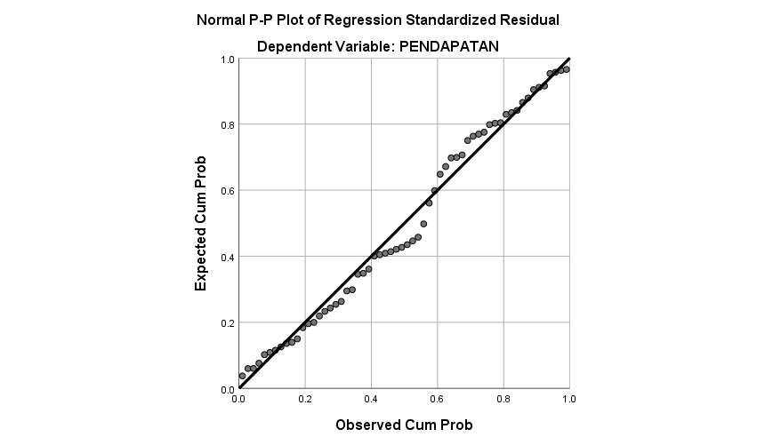
One-Sample Kolmogorov-Smirnov Test
 |  | Unstandardized Residual
N |  | 60
Normal Parameters^{a,b} | Mean | .0000000
Normal Parameters^{a,b} | Std. Deviation | 1.44695672
Most Extreme Differences | Absolute | .094
Most Extreme Differences | Positive | .094
Most Extreme Differences | Negative | -.076
Test Statistic |  | .094
Asymp. Sig. (2-tailed) |  | .200^{c,d}
a. Test distribution is Normal.
b. Calculated from data.
c. Lilliefors Significance Correction.
d. This is a lower bound of the true significance.

Uji Multikolinearitas
Coefficientsª
Model |  | Unstandardized Coefficients |  | Standardized Coefficients | t | Sig. | Collinearity Statistics
 |  | B | Std. Error | Beta | t | Sig. | Tolerance | VIF
1 | (Constant) | 5.843 | 2.460 |  | 2.375 | .021
1 | MODAL | -.384 | .093 | -.323 | -4.109 | .000 | .912 | 1.096
1 | HARGA | .235 | .092 | .234 | 2.548 | .014 | .669 | 1.496
1 | TENAGA KERJA | .269 | .074 | .341 | 3.630 | .001 | .640 | 1.562
1 | LUAS LAHAN | .315 | .122 | .229 | 2.573 | .013 | .714 | 1.401
1 | JUMLAH PRODUKSI | .401 | .112 | .330 | 3.574 | .001 | .660 | 1.515
a. Dependent Variable: PENDAPATAN

Uji Heteroskedastisitas
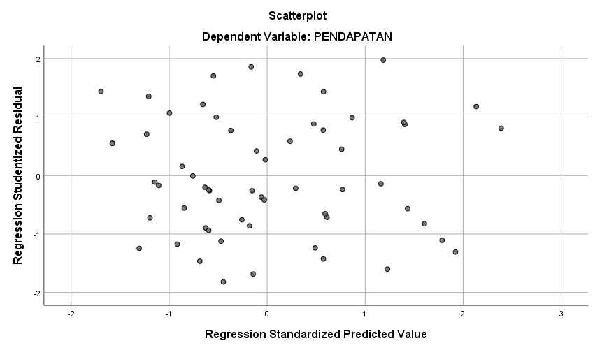

Koefisien determinasi (R²)
Model Summary
Model | R | R Square | Adjusted R Square | Std. Error of the Estimate
1 | .834ª | .695 | .667 | 1.512
a. Predictors: (Constant), JUMLAH PRODUKSI, MODAL, HARGA, LUAS LAHAN, TENAGA KERJA

Uji t
Coefficientsª
Model |  | Unstandardized Coefficients |  | Standardized Coefficients | t | Sig.
 |  | B | Std. Error | Beta | t | Sig.
1 | (Constant) | 5.843 | 2.460 |  | 2.375 | .021
1 | MODAL | -.384 | .093 | -.323 | -4.109 | .000
1 | HARGA | .235 | .092 | .234 | 2.548 | .014
1 | TENAGA KERJA | .269 | .074 | .341 | 3.630 | .001
1 | LUAS LAHAN | .315 | .122 | .229 | 2.573 | .013
1 | JUMLAH PRODUKSI | .401 | .112 | .330 | 3.574 | .001
a. Dependent Variable: PENDAPATAN

Uji F
ANOVAª
Model |  | Sum of Squares | df | Mean Square | F | Sig.
1 | Regression | 281.806 | 5 | 56.361 | 24.638 | .000^{b}
1 | Residual | 123.527 | 54 | 2.288
1 | Total | 405.333 | 59
a. Dependent Variable: PENDAPATAN
b. Predictors: (Constant), JUMLAH PRODUKSI, MODAL, HARGA, LUAS LAHAN, TENAGA KERJA

Analisis Regresi Linear Berganda
Coefficientsª
Model |  | Unstandardized Coefficients |  | Standardized Coefficients | t | Sig.
 |  | B | Std. Error | Beta | t | Sig.
1 | (Constant) | 5.843 | 2.460 |  | 2.375 | .021
1 | MODAL | -.384 | .093 | -.323 | -4.109 | .000
1 | HARGA | .235 | .092 | .234 | 2.548 | .014
1 | TENAGA KERJA | .269 | .074 | .341 | 3.630 | .001
1 | LUAS LAHAN | .315 | .122 | .229 | 2.573 | .013
1 | JUMLAH PRODUKSI | .401 | .112 | .330 | 3.574 | .001
a. Dependent Variable: PENDAPATAN

Uji Validitas
Correlations
 |  | X1.1 | X1.2 | X1.3 | X1.4 | TOTALX1
X1.1 | Pearson Correlation | 1 | .494** | .535** | .426* | .794**
X1.1 | Sig. (2-tailed) |  | .006 | .002 | .019 | .000
X1.1 | N | 30 | 30 | 30 | 30 | 30
X1.2 | Pearson Correlation | .494** | 1 | .641** | .275 | .750**
X1.2 | Sig. (2-tailed) | .006 |  | .000 | .142 | .000
X1.2 | N | 30 | 30 | 30 | 30 | 30
X1.3 | Pearson Correlation | .535** | .641** | 1 | .553** | .852**
X1.3 | Sig. (2-tailed) | .002 | .000 |  | .002 | .000
X1.3 | N | 30 | 30 | 30 | 30 | 30
X1.4 | Pearson Correlation | .426* | .275 | .553** | 1 | .738**
X1.4 | Sig. (2-tailed) | .019 | .142 | .002 |  | .000
X1.4 | N | 30 | 30 | 30 | 30 | 30
TOTALX1 | Pearson Correlation | .794** | .750** | .852** | .738** | 1
TOTALX1 | Sig. (2-tailed) | .000 | .000 | .000 | .000
TOTALX1 | N | 30 | 30 | 30 | 30 | 30
**. Correlation is significant at the 0.01 level (2-tailed).
*. Correlation is significant at the 0.05 level (2-tailed).

Correlations
 |  | X2.1 | X2.2 | X2.3 | X2.4 | TOTALX2
X2.1 | Pearson Correlation | 1 | .790** | .768** | .789** | .919**
X2.1 | Sig. (2-tailed) |  | .000 | .000 | .000 | .000
X2.1 | N | 30 | 30 | 30 | 30 | 30
X2.2 | Pearson Correlation | .790** | 1 | .815** | .780** | .919**
X2.2 | Sig. (2-tailed) | .000 |  | .000 | .000 | .000
X2.2 | N | 30 | 30 | 30 | 30 | 30
X2.3 | Pearson Correlation | .768** | .815** | 1 | .825** | .926**
X2.3 | Sig. (2-tailed) | .000 | .000 |  | .000 | .000
X2.3 | N | 30 | 30 | 30 | 30 | 30
X2.4 | Pearson Correlation | .789** | .780** | .825** | 1 | .912**
X2.4 | Sig. (2-tailed) | .000 | .000 | .000 |  | .000
X2.4 | N | 30 | 30 | 30 | 30 | 30
TOTALX2 | Pearson Correlation | .919** | .919** | .926** | .912** | 1
TOTALX2 | Sig. (2-tailed) | .000 | .000 | .000 | .000
TOTALX2 | N | 30 | 30 | 30 | 30 | 30
**. Correlation is significant at the 0.01 level (2-tailed).

Correlations
 |  | X3.1 | X3.2 | X3.3 | X3.4 | X3.5 | X3.6 | TOTALX3
X3.1 | Pearson Correlation | 1 | .674** | .498** | .297 | .232 | .451* | .661**
X3.1 | Sig. (2-tailed) |  | .000 | .005 | .112 | .218 | .012 | .000
X3.1 | N | 30 | 30 | 30 | 30 | 30 | 30 | 30
X3.2 | Pearson Correlation | .674** | 1 | .455* | .542** | .306 | .233 | .633**
X3.2 | Sig. (2-tailed) | .000 |  | .011 | .002 | .100 | .215 | .000
X3.2 | N | 30 | 30 | 30 | 30 | 30 | 30 | 30
X3.3 | Pearson Correlation | .498** | .455* | 1 | .505** | .556** | .673** | .886**
X3.3 | Sig. (2-tailed) | .005 | .011 |  | .004 | .001 | .000 | .000
X3.3 | N | 30 | 30 | 30 | 30 | 30 | 30 | 30
X3.4 | Pearson Correlation | .297 | .542** | .505** | 1 | .638** | .484** | .726**
X3.4 | Sig. (2-tailed) | .112 | .002 | .004 |  | .000 | .007 | .000
X3.4 | N | 30 | 30 | 30 | 30 | 30 | 30 | 30
X3.5 | Pearson Correlation | .232 | .306 | .556** | .638** | 1 | .515** | .698**
X3.5 | Sig. (2-tailed) | .218 | .100 | .001 | .000 |  | .004 | .000
X3.5 | N | 30 | 30 | 30 | 30 | 30 | 30 | 30
X3.6 | Pearson Correlation | .451* | .233 | .673** | .484** | .515** | 1 | .817**
X3.6 | Sig. (2-tailed) | .012 | .215 | .000 | .007 | .004 |  | .000
X3.6 | N | 30 | 30 | 30 | 30 | 30 | 30 | 30
TOTALX3 | Pearson Correlation | .661** | .633** | .886** | .726** | .698** | .817** | 1
TOTALX3 | Sig. (2-tailed) | .000 | .000 | .000 | .000 | .000 | .000
TOTALX3 | N | 30 | 30 | 30 | 30 | 30 | 30 | 30
**. Correlation is significant at the 0.01 level (2-tailed).
*. Correlation is significant at the 0.05 level (2-tailed).

Correlations
 |  | x4.1 | x4.2 | x4.3 | x4.4 | x4.5 | totalx4
x4.1 | Pearson Correlation | 1 | .889** | .827** | .444* | .635** | .932**
x4.1 | Sig. (2-tailed) |  | .000 | .000 | .014 | .000 | .000
x4.1 | N | 30 | 30 | 30 | 30 | 30 | 30
x4.2 | Pearson Correlation | .889** | 1 | .853** | .359 | .725** | .923**
x4.2 | Sig. (2-tailed) | .000 |  | .000 | .051 | .000 | .000
x4.2 | N | 30 | 30 | 30 | 30 | 30 | 30
x4.3 | Pearson Correlation | .827** | .853** | 1 | .317 | .486** | .837**
x4.3 | Sig. (2-tailed) | .000 | .000 |  | .087 | .007 | .000
x4.3 | N | 30 | 30 | 30 | 30 | 30 | 30
x4.4 | Pearson Correlation | .444* | .359 | .317 | 1 | .390* | .644**
x4.4 | Sig. (2-tailed) | .014 | .051 | .087 |  | .033 | .000
x4.4 | N | 30 | 30 | 30 | 30 | 30 | 30
x4.5 | Pearson Correlation | .635** | .725** | .486** | .390* | 1 | .759**
x4.5 | Sig. (2-tailed) | .000 | .000 | .007 | .033 |  | .000
x4.5 | N | 30 | 30 | 30 | 30 | 30 | 30
totalx4 | Pearson Correlation | .932** | .923** | .837** | .644** | .759** | 1
totalx4 | Sig. (2-tailed) | .000 | .000 | .000 | .000 | .000
totalx4 | N | 30 | 30 | 30 | 30 | 30 | 30
**. Correlation is significant at the 0.01 level (2-tailed).
*. Correlation is significant at the 0.05 level (2-tailed).

Correlations
 |  | X5.1 | X5.2 | X5.3 | X5.4 | TOTALX5
X5.1 | Pearson Correlation | 1 | .707** | .524** | .816** | .919**
X5.1 | Sig. (2-tailed) |  | .000 | .003 | .000 | .000
X5.1 | N | 30 | 30 | 30 | 30 | 30
X5.2 | Pearson Correlation | .707** | 1 | .634** | .708** | .871**
X5.2 | Sig. (2-tailed) | .000 |  | .000 | .000 | .000
X5.2 | N | 30 | 30 | 30 | 30 | 30
X5.3 | Pearson Correlation | .524** | .634** | 1 | .424* | .736**
X5.3 | Sig. (2-tailed) | .003 | .000 |  | .020 | .000
X5.3 | N | 30 | 30 | 30 | 30 | 30
X5.4 | Pearson Correlation | .816** | .708** | .424* | 1 | .877**
X5.4 | Sig. (2-tailed) | .000 | .000 | .020 |  | .000
X5.4 | N | 30 | 30 | 30 | 30 | 30
TOTALX5 | Pearson Correlation | .919** | .871** | .736** | .877** | 1
TOTALX5 | Sig. (2-tailed) | .000 | .000 | .000 | .000
TOTALX5 | N | 30 | 30 | 30 | 30 | 30
**. Correlation is significant at the 0.01 level (2-tailed).
*. Correlation is significant at the 0.05 level (2-tailed).

Correlations
 |  | Y1 | Y2 | Y3 | Y4 | Y5 | Y6 | TOTAL_Y
Y1 | Pearson Correlation | 1 | .645** | .746** | .613** | .314 | .772** | .858**
Y1 | Sig. (2-tailed) |  | .000 | .000 | .000 | .091 | .000 | .000
Y1 | N | 30 | 30 | 30 | 30 | 30 | 30 | 30
Y2 | Pearson Correlation | .645** | 1 | .787** | .633** | .444* | .683** | .860**
Y2 | Sig. (2-tailed) | .000 |  | .000 | .000 | .014 | .000 | .000
Y2 | N | 30 | 30 | 30 | 30 | 30 | 30 | 30
Y3 | Pearson Correlation | .746** | .787** | 1 | .705** | .464** | .690** | .912**
Y3 | Sig. (2-tailed) | .000 | .000 |  | .000 | .010 | .000 | .000
Y3 | N | 30 | 30 | 30 | 30 | 30 | 30 | 30
Y4 | Pearson Correlation | .613** | .633** | .705** | 1 | .418* | .487** | .824**
Y4 | Sig. (2-tailed) | .000 | .000 | .000 |  | .022 | .006 | .000
Y4 | N | 30 | 30 | 30 | 30 | 30 | 30 | 30
Y5 | Pearson Correlation | .314 | .444* | .464** | .418* | 1 | .272 | .543**
Y5 | Sig. (2-tailed) | .091 | .014 | .010 | .022 |  | .147 | .002
Y5 | N | 30 | 30 | 30 | 30 | 30 | 30 | 30
Y6 | Pearson Correlation | .772** | .683** | .690** | .487** | .272 | 1 | .818**
Y6 | Sig. (2-tailed) | .000 | .000 | .000 | .006 | .147 |  | .000
Y6 | N | 30 | 30 | 30 | 30 | 30 | 30 | 30
TOTAL_Y | Pearson Correlation | .858** | .860** | .912** | .824** | .543** | .818** | 1
TOTAL_Y | Sig. (2-tailed) | .000 | .000 | .000 | .000 | .002 | .000
TOTAL_Y | N | 30 | 30 | 30 | 30 | 30 | 30 | 30
**. Correlation is significant at the 0.01 level (2-tailed).
*. Correlation is significant at the 0.05 level (2-tailed).

9. Uji Reliabilitas
- Modal
Reliability Statistics
Cronbach's Alpha | N of Items
.781 | 4

- Harga
Reliability Statistics
Cronbach's Alpha | N of Items
.933 | 4

- Tenaga Kerja
Reliability Statistics
Cronbach's Alpha | N of Items
.808 | 6

- Luas Lahan
Reliability Statistics
Cronbach's Alpha | N of Items
.860 | 5

- Jumlah Produksi
Reliability Statistics
Cronbach's Alpha | N of Items
.861 | 4

- Pendapatan
Reliability Statistics
Cronbach's Alpha | N of Items
.888 | 6

